Encompass Service Provider Listing and Setup

Encompass Service Provider Listing
Services that do NOT require a login from the user:

Underwriting
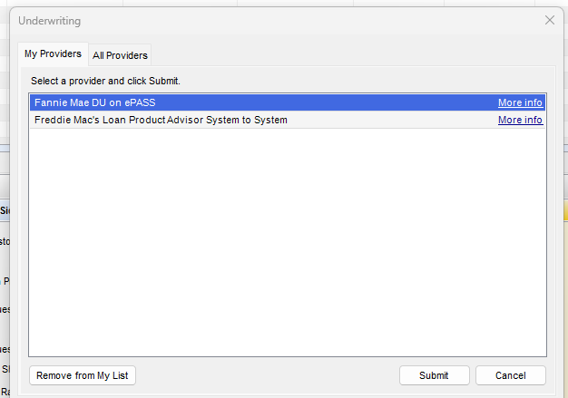

Flood Vendors
*Note – ICE Enhanced Flood Report is now our default Flood Vendor
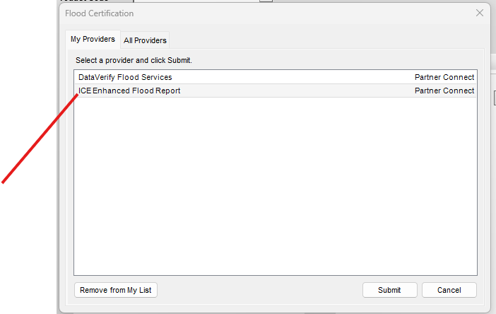

Fraud Review

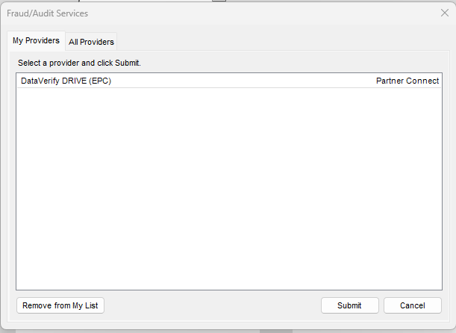

USPS – Loan Template Setup and Property Tax Lookup (Ice Fees)
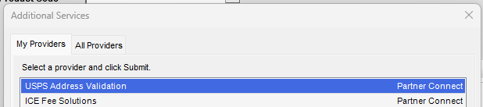

Encompass Service Provider Listing
Services that DO require a login from the user:

Credit:
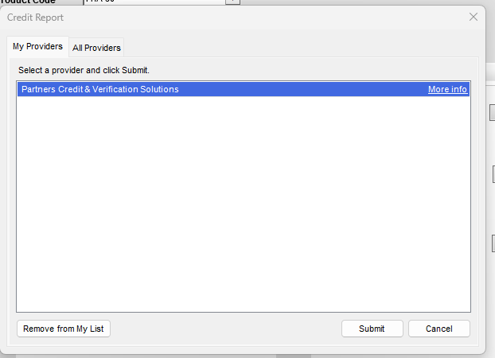

FHA Connections:
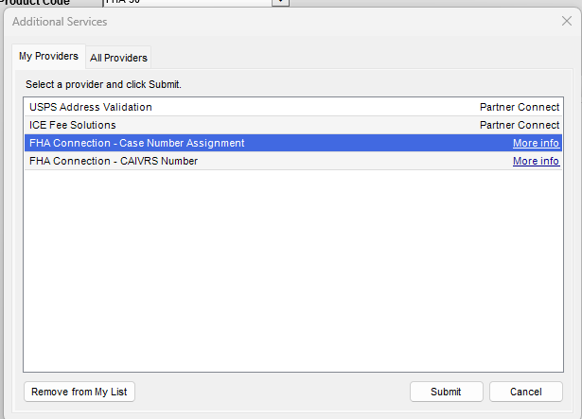

Mercury (Appraisal Ordering):
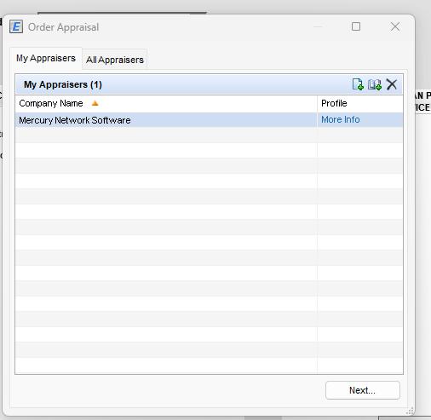

How Do I add these Providers in Encompass?
Within Encompass, all users must set up their Service Provider Views. The first time you add a vendor (Service to order), you will all providers that are associated with Encompass for each service. This as an example for running AUS:
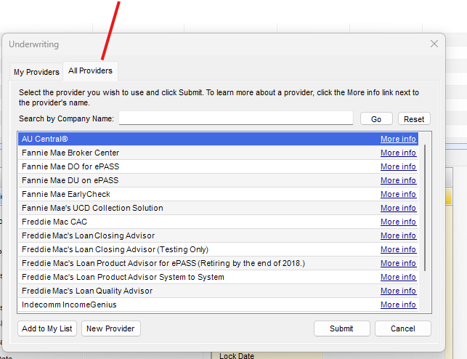

Please see the screen shots below to add them to “My Providers” for future use so you do not need to select them from the “All Providers” menu each time.

Screen shots:
