Steps to send Order Forms or Other Custom and Standard Print Forms

Step #1 – Select the form you want to print. Remember, that if you are on a standard input form within Encompass it automatically will reference the print form while you are on that form. Make sure to print “Add to the E-Folder”.

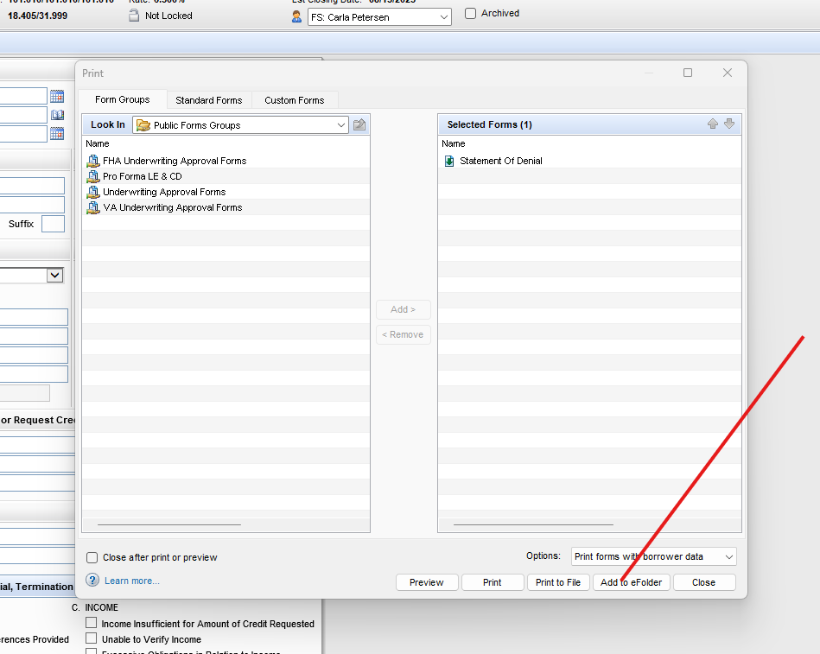

Step #2 – Go to the E-Folder.
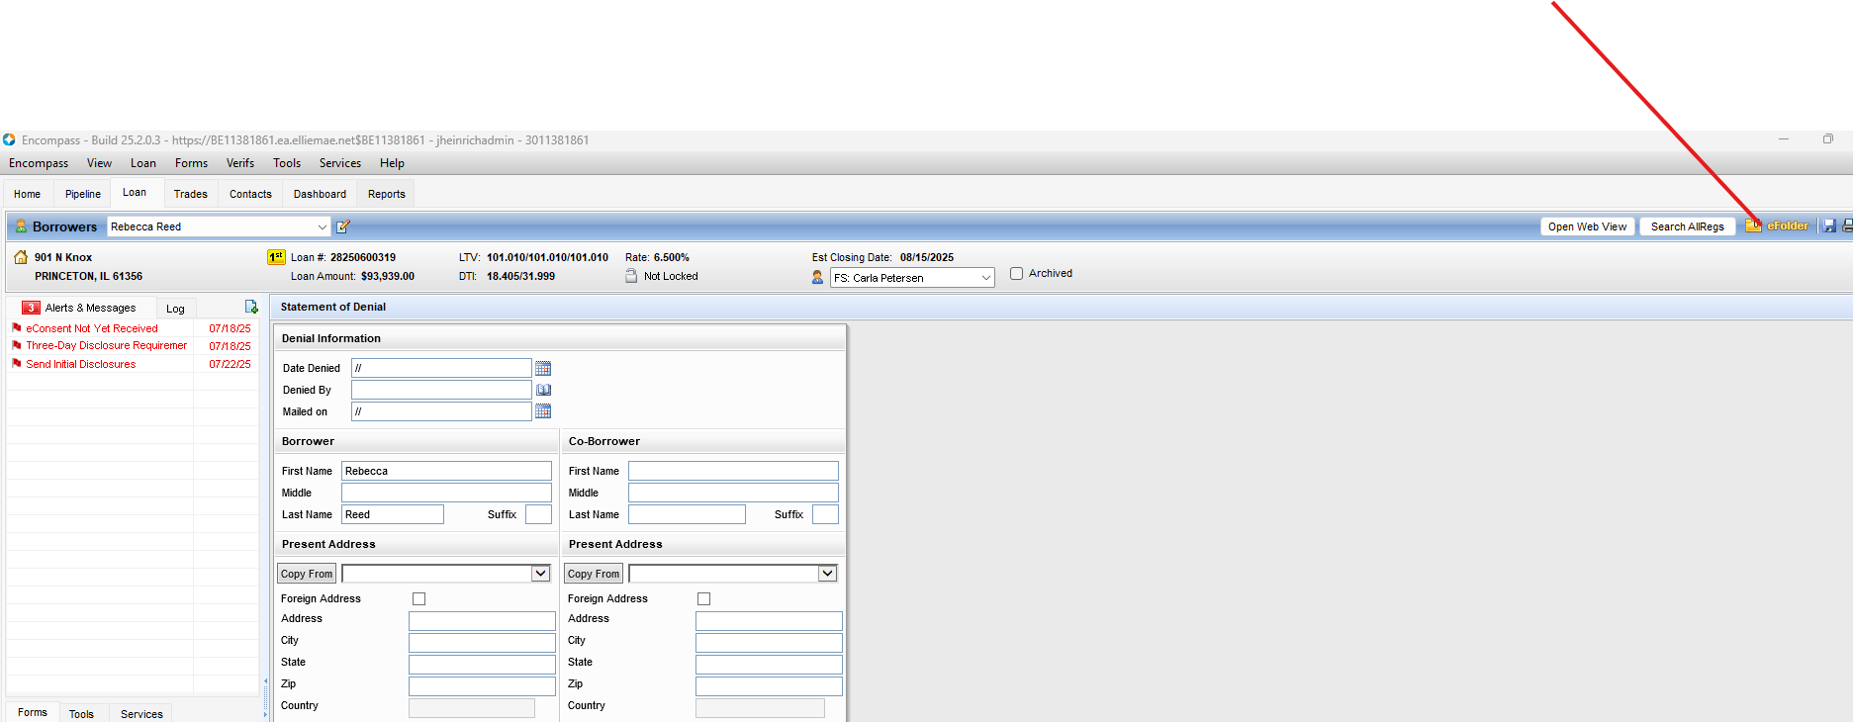

Step #3 – Add the actual Document Folder (Bucket) so you can place the form within it in the E-Folder.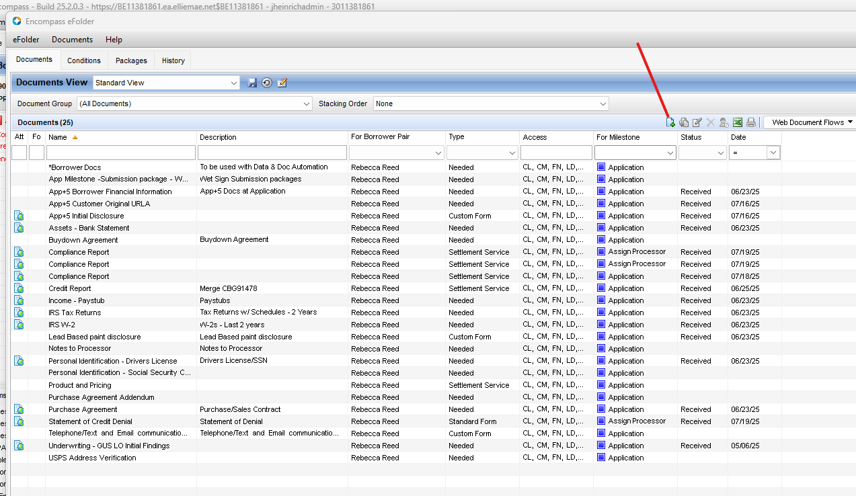

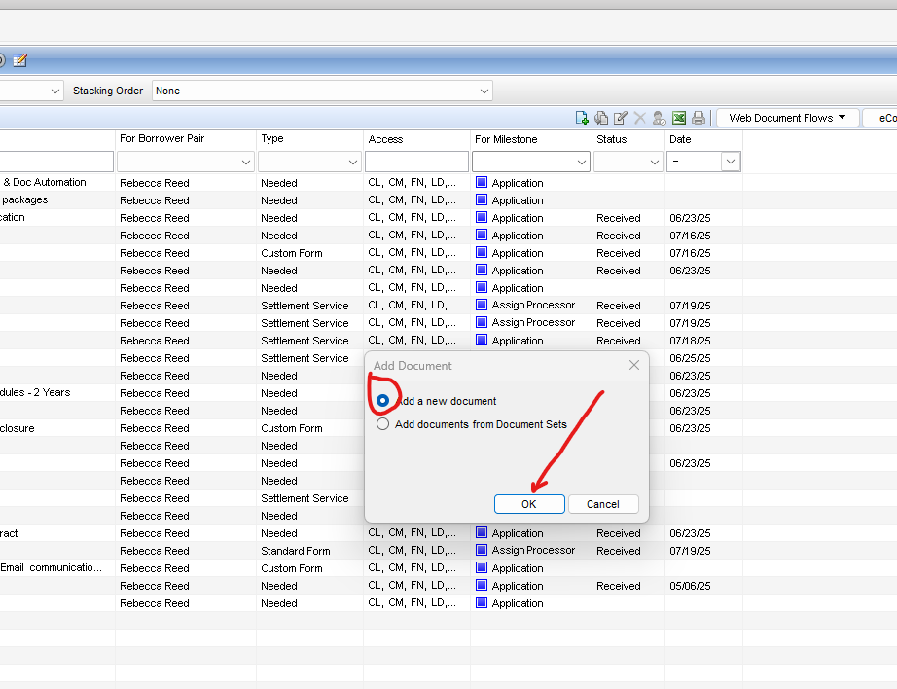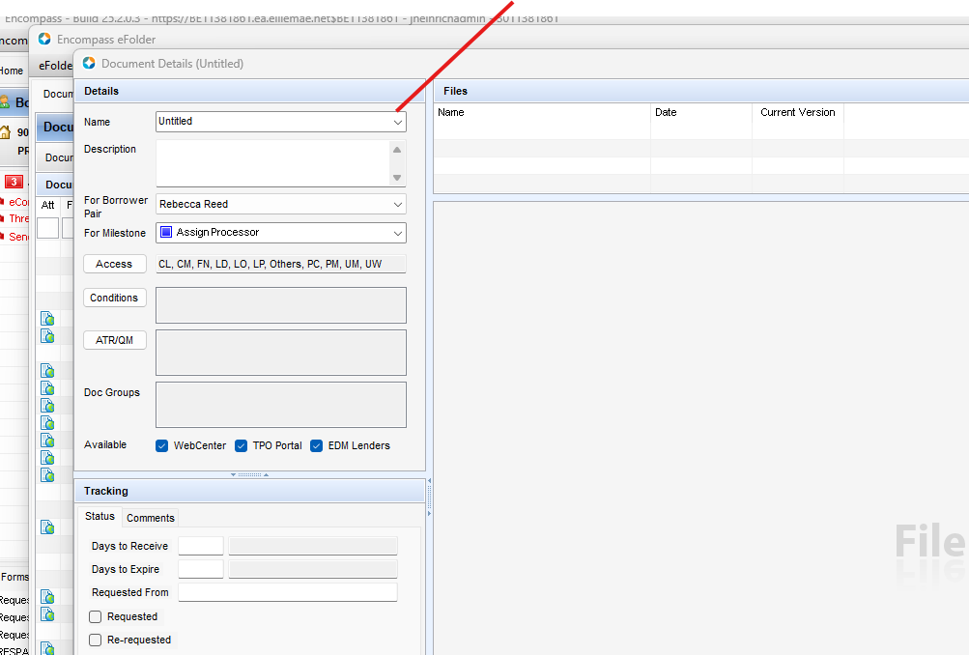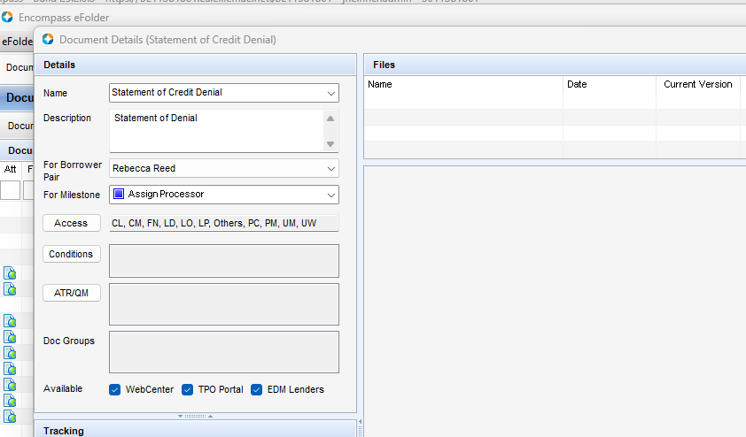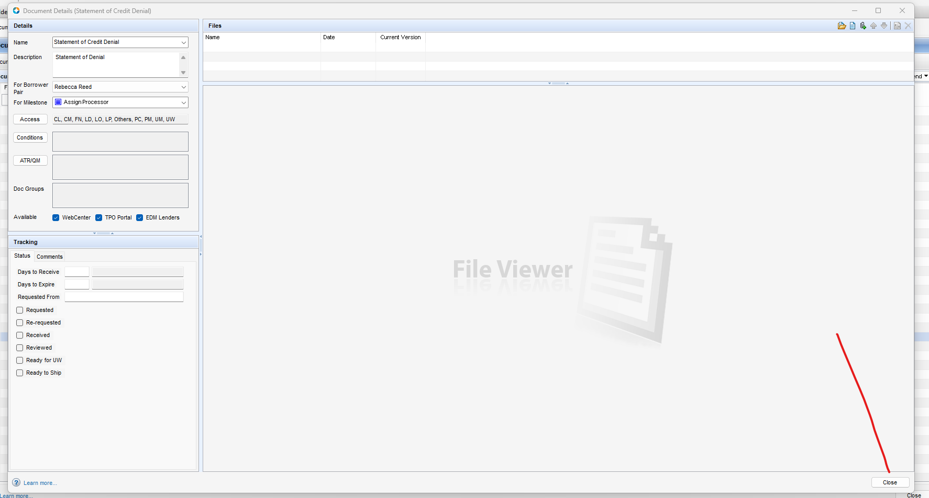

Step #4 – Move the Form to the Document (Folder/Bucket) you added: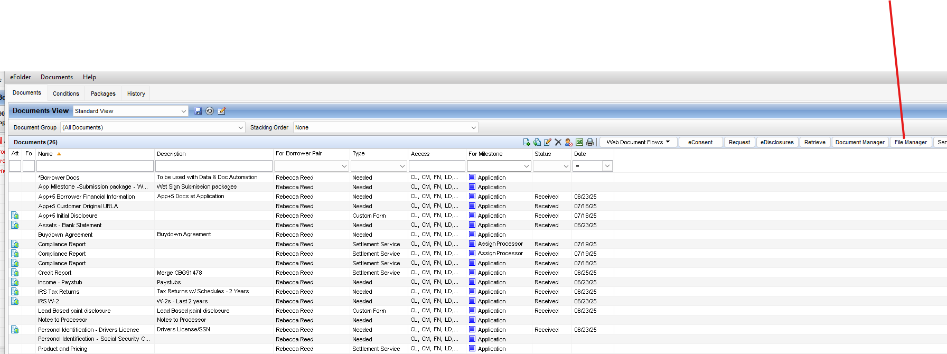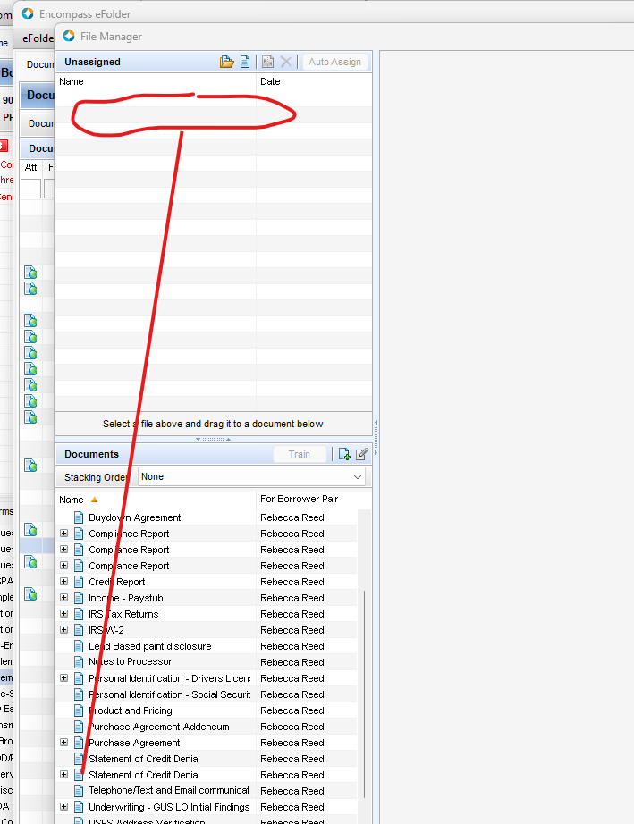

Step #5 – Select the “Send” option from the E-Folder Menu and select the document you want to send.

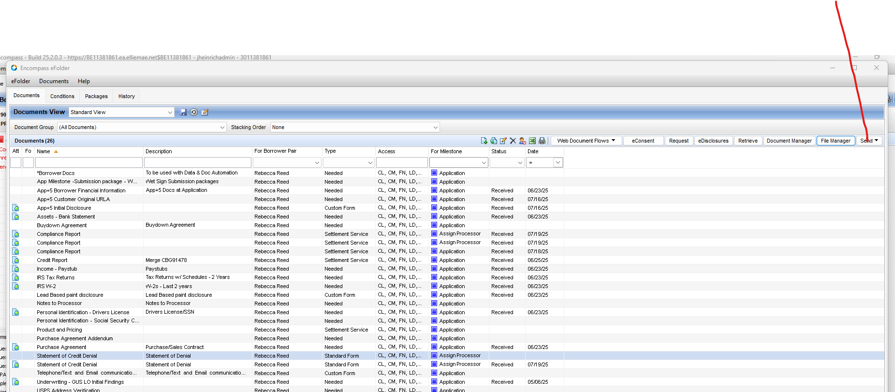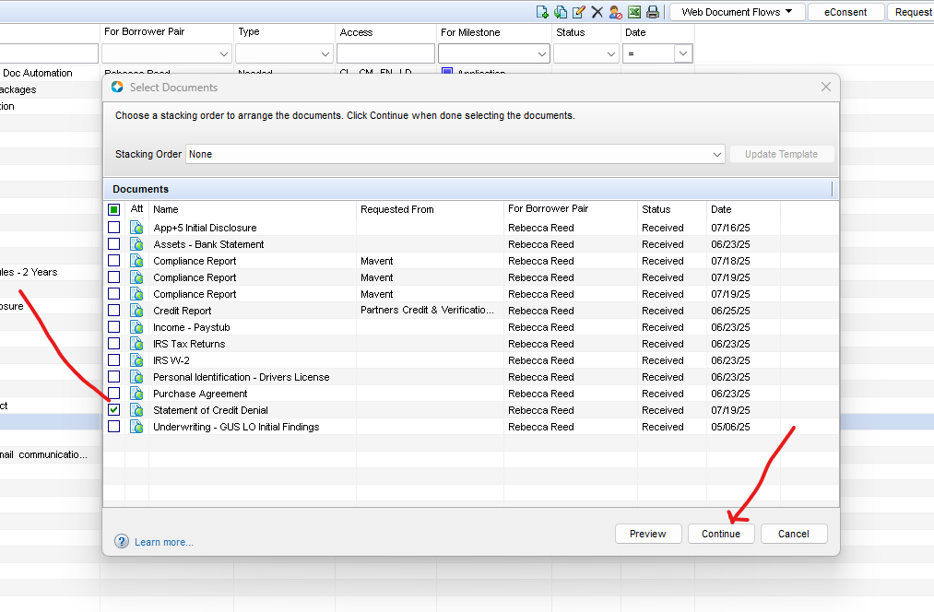

Step #6 – Select the correct Email Template from the drop-down and add the business contact you want to send the document to. You may have to add additional contacts under the “Tools” menu and go to the “File Contacts” page first.