You have an alternative loan product and you and APT have determined what product and what lender…. What’s next:

When starting an APT loan

Step Number 1 – Initial Encompass Loan Setup:
- Before starting anything go to Easy Data Entry and complete the following:
  - Product Code
  - Investor Name
  - Once you are done entering this information please save the file. You will see that our rule base will setup the milestones to reflect the brokered loan process instead of a regular Agency loan automatically.

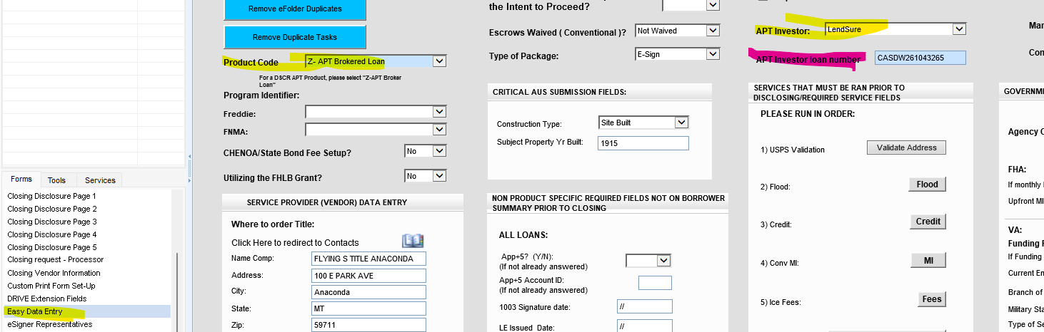
- Navigate to the Top Left of the Borrower’s Summary Origination Form within Encompass. If this field (2626) does not say broker, please reach out to MIT right away.

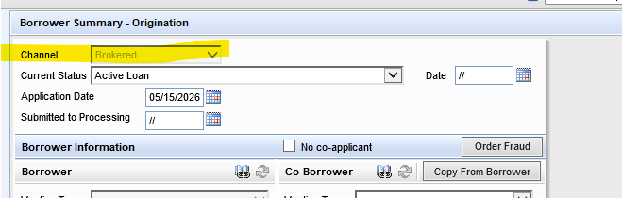
- Later you will get the investor loan number. Once you have started the file with the lender. Please enter it at that time!

- Once the loan is stated as a Brokered loan, you will NOT be able to send out disclosures or change the loan back to an agency loan product.

  - If later you want to do an Agency loan for the same applicants, you must start a whole new loan within Encompass. We suggest you use the export and import option, but you can also duplicate the loan to start over.
  - If after researching an APT loan and the applicants no longer qualify and you need to DENY the loan, remember that all brokered loan products must be denied under the “Prequal Denial” section on the denial form within Encompass. Please also remember to finish the application milestone for our Compliance team to receive that automated email. Brokered loans are NOT HMDA reportable, hence this policy.

Step Number 2 – Starting the APT Loan within Encompass once ready for Lender Submission:

Now enter the following information for processing and commission purposes.
- Now it is time to complete the URLA- TAKE A FULL APPLICATION-Make sure the info you are entering is correct This will save you or your processor time later throughout the process by being able to export the full application and import it to the lender’s website.
  - Except for HELOC loans, and ITIN (see notes below for these two types) you should be importing your credit report. You cannot determine if you have a potential qualified borrower without a credit report.
- Loan Amount
- Interest Rate
- Loan Term
- You can add more to the Easy Data Page that may help your processor later:
  - Title company
  - Homeowner’s insurance company
  - Notes to the processor

Step Number 3 – Preparing each loan for processing / Lender Submission:

This is also a good time to send out a borrower’s authorization for Flanagan State bank- the reason: the borrower will sign one with the lender that is being used, but that form will not let us order verifications and credit supplements. We need to have one with Flanagan State Bank in the file manager so the processor can process.

Most of the lenders will need our 1003 and/or a 3.4 (see below if lenders require specific information on the URLA- example, Lendsure requires subject address to be listed as TBD for a purchase file -you can add address once you have created your 3.4 file-see below), if the file is a DSCR, you won’t add income on page 2, bank statement or P&L loans, add the income that has been determined by the chosen lender during the prequalification stage) -

Steps for Creating the 3.4
Once your file is ready to create a 3.4 here are the steps-
- Exit your file and go to your pipeline view.
- Rt click on the loan
- Scroll to GSE Services
- Go to ULAD (DU MISMO 3.4) or the iLad (MISMO 3.4) this will be noted on the specific lender instructions.
- Download and save it to your desktop, this will be sent once ready


Heloc –With REMN, they will pull a soft pull themselves, but it’s a good idea to have your own. Forward Lending also requires just a soft pull
ITIN-The lender will pull their own report – TRANSUNION only, but it’s also a good idea to do a soft pull for Transunion yourself as well.

LendSure Processing Guide

Account Setup
Need Portal Access?
APT can assist with obtaining your Lendsure login credentials.
Contact:
- Email: tdavis@mtgbyallison.com
- Phone: 765-413-8806

Account Executive
Leslie Chambers
- Phone: 513-587-5973
- Email: lchambers@lendsure.com

Broker Portal
Login: https://lendsure.my.site.com/s/login/
Training Portal: https://lendsure.my.site.com/s/training/
Once your login has been created, log into the Training Portal and review all available Scribe training guides before processing your first file.

Loan Process

Step 1 – Starting the pre-qualification
When setting up a purchase file in Encompass:
- The property address will populate as TBD on the 1003 (3.4) LendSure will require the ULAD (DU MISMO 3.4) for compliance purposes.
- The Loan Officer may complete the initial setup because pricing selections are required before processing.
In the Training Portal, review:
How to Submit a Pre-Qualification in the Broker Portal
This guide walks through:
- Uploading documents
- Completing the loan submission
- Verifying loan information
- Communicating with your Account Executive
- Tips for faster approvals

Typical Pre-Qualification Documents
Upload the following whenever possible:
- PDF 1003
- 3.4) Lendsure will require the ULAD (DU MISMO 3.4)
- Broker-pulled credit report
- Income documentation
- Two most recent bank statements
- Any additional supporting documentation
Note: Operations may request additional documentation before issuing pre-approval.

Step 2 – Submit for Disclosures
Once the loan receives a pre-approval:
Review the Scribe:
How to Submit a Loan for Disclosures in the Broker Portal
This guide explains:
- Submitting the loan for disclosures
- Verifying compensation
- Confirming loan information
- Avoiding common submission errors
At this stage, upload:
- Income documentation
- Asset documentation
- Any remaining documents needed for full underwriting
Wait until disclosures have been signed before proceeding.

Step 3 – Order the Appraisal
After disclosures are complete:
Order the appraisal through Mercury.
If you experience any issues with Mercury, contact APT.
Effective 07/20/2026: An AMC is not required.

Step 4 – Conditional Approval
Once the file receives a Conditional Approval:
Continue uploading all requested conditions directly through the Broker Portal.
Review the Training Portal Scribe:
How to Upload Conditions in the Broker Portal
It is recommended that you continue to update Encompass, if you run into issues with DTI, cash to close or anything else, you want to make sure you have the same approved income and assets etc. The lender has a system we don’t see, and if we are needing to argue anything we really want to make sure we are matching with them or at least know what they have so we can have a valid debate/argument. Most of this information is on the loan conditional approval.

Step 5 – Closing
The assigned processor will:
- Send condition updates
- Provide the fee sheet/closing worksheet
- Coordinate preparation of the Closing Disclosure (CD)
Although much of the closing process occurs behind the scenes, the workflow is generally smooth once the CD process begins.

Step 6 – Funding
Once the loan has been funded:
Update loan amount, income assets etc. in encompass, to match the final approval from the lender and then let APT know the file has funded.
Email: apt@flanaganstatebank.com
Title will need to mail the broker check- the address they will need to mail this to is:
Flanagan State Bank
Attention: Loan Servicing
P.O. Box 368 (needs to be listed for regular mail)
301 W. Falcon Hwy.
Flanagan, IL 61740

Mortgagee Clauses

Title & CPL Mortgagee Clause
LendSure Mortgage Corp. ISAOA
12230 World Trade Drive, Suite 250
San Diego, CA 92128

Hazard Insurance Mortgagee Clause
Cornerstone Servicing ISAOA
PO Box 961254
Fort Worth, TX 76161

Important Notes

Expected Timeline
LendSure estimates approximately 45 days from pre-approval to closing.
Set realistic closing dates and ensure all parties understand this timeline.

Broker Compensation
LendSure allows the broker fee to be rolled into the borrower's closing costs.
This can be beneficial for borrowers with cash flow concerns.
Note: This feature is unique to Lendsure.

Loan Products
LendSure offers:
- DSCR Loans
- Asset Qualification Loans
- Bridge Loans
- Fix & Flip Loans

Training Resources
Training Portal
https://lendsure.my.site.com/s/training/
Access requires your assigned username and password.
Be sure to review all available Scribe guides before processing files independently.

Please call, email or message me on teams if you need any help with anything. How to complete a step, understanding a condition, or a specific process.
We are considered the broker, and the APT investor is considered the lender.

