Soft pull instructions
- Access the DataVerify report.
- Click Edit Loan Input
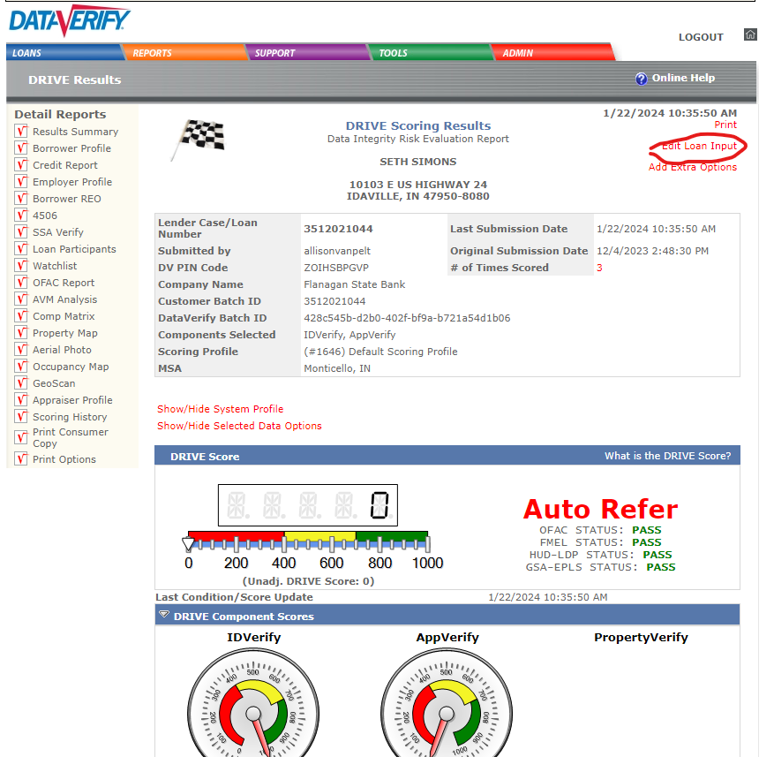

- Click credit report and then the run scoring button.
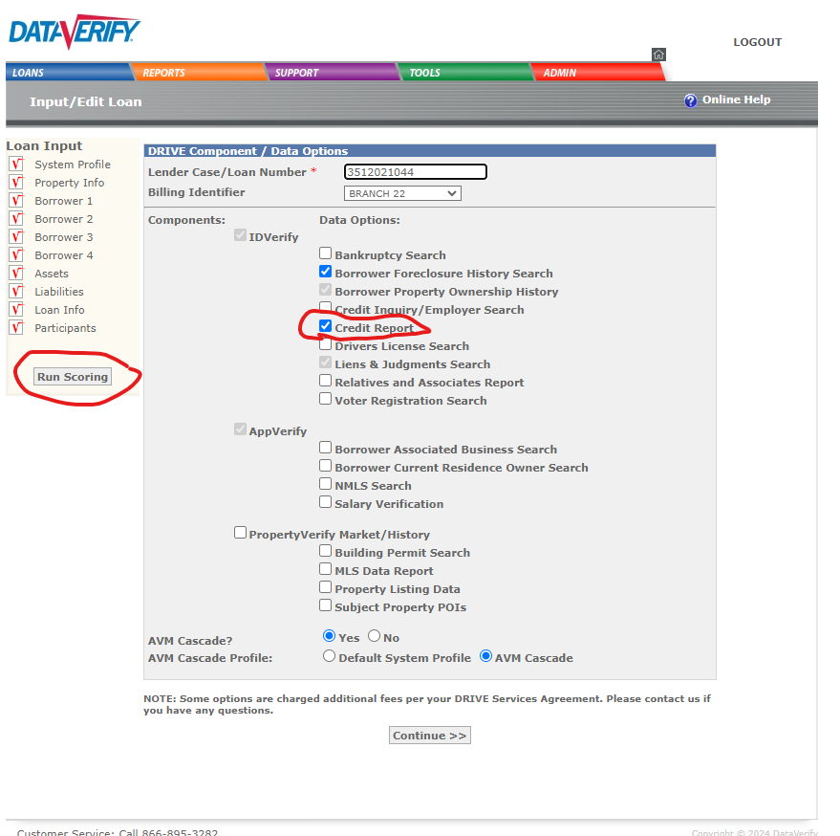

- This will take you back to the Detail Reports where you will select credit report.
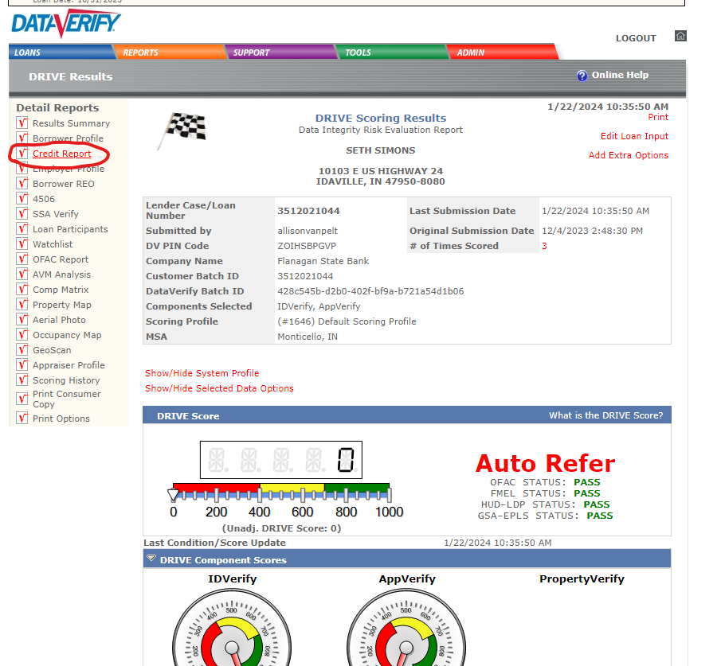
- Click View and it will bring up your soft pull.
