You have an alternative loan product and you and APT have determined what product and what lender…. What’s next:

When starting an APT loan

Step Number 1 – Initial Encompass Loan Setup:
- Before starting anything go to Easy Data Entry and complete the following:
  - Product Code
  - Investor Name
  - Once you are done entering this information please save the file. You will see that our rule base will setup the milestones to reflect the brokered loan process instead of a regular Agency loan automatically.

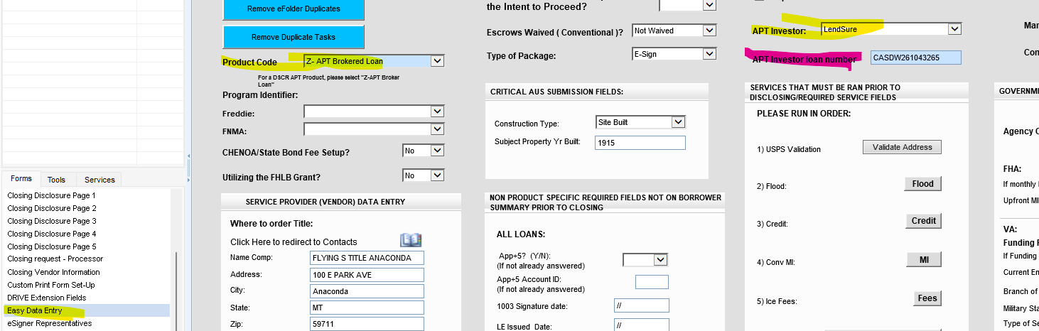
- Navigate to the Top Left of the Borrower’s Summary Origination Form within Encompass. If this field (2626) does not say broker, please reach out to MIT right away.

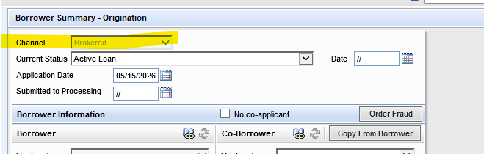
- Later you will get the investor loan number. Once you have started the file with the lender. Please enter it at that time!

- Once the loan is stated as a Brokered loan, you will NOT be able to send out disclosures or change the loan back to an agency loan product.

  - If later you want to do an Agency loan for the same applicants, you MUST start a whole new loan within Encompass. We suggest you use the export and import option. DO NOT duplicate the loan.
  - If after researching an APT loan and the applicants no longer qualify and you need to DENY the loan, remember that all brokered loan products must be denied under the “Prequal Denial” section on the denial form within Encompass. Please also remember to finish the application milestone for our Compliance team to receive that automated email. Brokered loans are NOT HMDA reportable, hence this policy.

Step Number 2 – Starting the APT Loan within Encompass once ready for Lender Submission:

Now enter the following information for processing and commission purposes.
- Now it is time to complete the URLA- TAKE A FULL APPLICATION-Make sure the info you are entering is correct This will save you or your processor time later throughout the process by being able to export the full application and import it to the lender’s website.
  - Except for HELOC loans, and ITIN (see notes below for these two types) you should be importing your credit report. You cannot determine if you have a potential qualified borrower without a credit report.
- Loan Amount
- Interest Rate
- Loan Term
- You can add more to the Easy Data Page that may help your processor later:
  - Title company
  - Homeowner’s insurance company
  - Notes to the processor

Step Number 3 – Preparing each loan for processing / Lender Submission:

This is also a good time to send out a borrower’s authorization for Flanagan State bank- the reason: the borrower will sign one with the lender that is being used, but that form will not let us order verifications and credit supplements. We need to have one with Flanagan State Bank in the file manager so the processor can process.

Most of the lenders will need our 1003 and/or a 3.4 (see below if lenders require specific information on the URLA- example, Lendsure requires subject address to be listed as TBD for a purchase file -you can add address once you have created your 3.4 file-see below), if the file is a DSCR, you won’t add income on page 2, bank statement or P&L loans, add the income that has been determined by the chosen lender during the prequalification stage) -

Steps for Creating the 3.4
Once your file is ready to create a 3.4 here are the steps-
- Exit your file and go to your pipeline view.
- Rt click on the loan
- Scroll to GSE Services
- Go to ULAD (DU MISMO 3.4) or the iLad (MISMO 3.4) this will be noted on the specific lender instructions.
- Download and save it to your desktop, this will be sent once ready
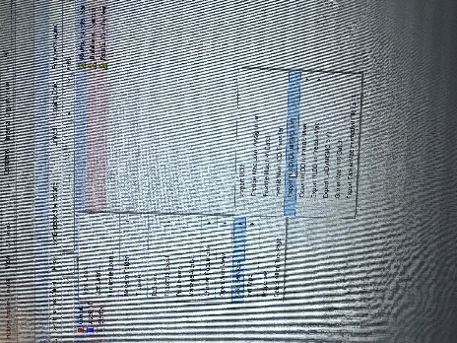

Heloan –With REMN, they will pull a soft pull themselves, but it’s a good idea to have your own. Forward Lending also requires just a soft pull, this can be pulled by the LO or the Forward Lending.
ITIN-The lender will pull their own report – TRANSUNION only, but it’s also a good idea to do a soft pull for Transunion yourself as well.

Processing Guide
Account Setup
Need Portal Access?
APT can assist with obtaining your login credentials.

Contact:
- Email: tdavis@mtgbyallison.com
- Phone: 765-413-8806

Account Executive
Eric Von Eps
- Email: eric.coneps@acralending.com
- Phone: 714-315-8280

Account Manager or (AM)- Seleena Walker
- Email: saleena.walker@acralending.com
- Phone: 949-298-2233
She is your POC with ACRA- you will contact her for CD’s, questions on UW conditions- she will manage the file until CTC

Login: https://alglide.com/
ACRA
NEW BROKER portal GLIDE for a NMLS broker

This will be for all NEW submitted loans

After you set up your password, now you can register and upload your NEW loan

Log into GLIDE
https://alglide.com/ - GLIDE Broker portal

Start:

1. From any page in Glide, top right click start application

2. then go to 3.4 XML OR by scratch (manually do application)

IF you are doing a NOO cash out loan, please make sure you submit the loan as a business cash out loan, NOT a personal cash out loan, thank you

Only do the INITIAL STEPS for now and then WAIT UNTIL AFTER the AM can review your application and price it out

DO NOT authorize and submit your loan until after the AM can review the application, confirm pricing, and review all the needs list of submitted documents

Once you submit the loan, Acra CANNOT make any changes or add anything OR take anything out, make sure you are giving the best chance to get your approval!

Please do NOT authorize and submit your loan until AFTER the AM is able to review the application and pricing and needs list to submit

Please let the AM know and he/she can go in and review your application & pricing and needs list BEFORE you hit the authorize & submit button

Notes for disclosures-
This is what the borrower will see
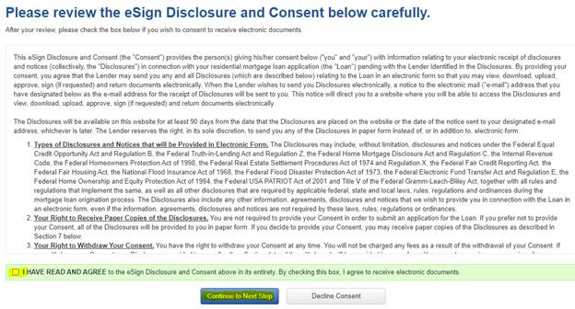
When borrower opens link that they received via email they will need to enter last 4 of SSN + a viewing code to open and sign documents:
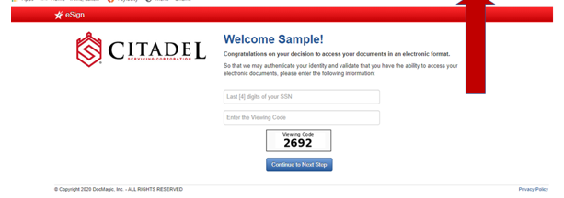
On the next screen they create their signature:
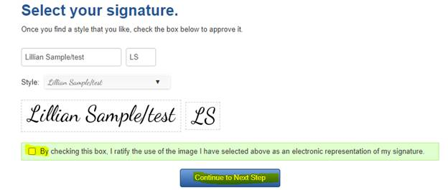
The next screen shows the disclosures and where the borrower needs to sign:
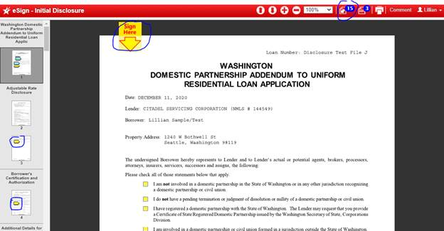

Borrower should sign documents until completion.

NOO INITIAL DISCLOSURES- NON TRID loan

After your NEW loan is submitted, the ACRA set up department will send out a very small skinny package of NOO disclosures to your borrower and send a copy to you as well

There will be NO interest rate on the pages, it will just be a few standard NOO disclosures that we are required to send to your borrower

Your borrower does not need to sign them or send back any of the initial disclosures

IF you have a Foreign National borrower, to open the NOO initial disc the last 4 digits should be all 1’s

Initial disclosures are based on how broker submits the loan.

The escrow/title fees are used off a template, the escrow & title company that the broker wants to use will be the company that are used

- ACRA just uses the estimated numbers from a default title and escrow company

- Later: The re-disclosures are based on how the loan is approved and it also shows the loan is locked, as well as any changes from the u/w on the taxes and insurance amounts.

- This estimated closing statement is what they will be used to issue the CD, with those escrow/title final fees. These fees are ONLY updated on the CD…………NEVER on an LE.
These are all just initial numbers without anyone adding or adjusting numbers

The numbers will be adjusted after the loan is approved and then the re disc will go out. The borrowers are NOT confirming or accepting any initial numbers, they are just allowing all parties to move forward
please have borrower respond/reply/e sign that they intend/intent to proceed (ITP)

Once disclosures are signed by your borrower, then you will receive confirmation by email from Doc Magic & CARLA, or the TM will give you the FINAL clear and the go ahead to move forward and then you can order the appraisal at anytime after the ITP is signed off

NOO INITIAL DISCLOSURES- NON TRID loan

After your NEW loan is submitted, the ACRA set up department will send out a very small skinny package of NOO disclosures to your borrower and send a copy to you as well

There will be NO interest rate on the pages, it will just be a few standard NOO disclosures that we are required to send to your borrower

Your borrower does not need to sign them or send back any of the initial disclosures

IF you have a Foreign National borrower, to open the NOO initial disc the last 4 digits should be all 1’s

Please have your borrower save them

How to view disclosures after they are uploaded into GLIDE

- GO into GLIDE

- GO to pipeline (top middle of page)

- Go to your loan #

- Go to important dates (middle left of page)

- Says disclosure history

- disclosures attached below (example)

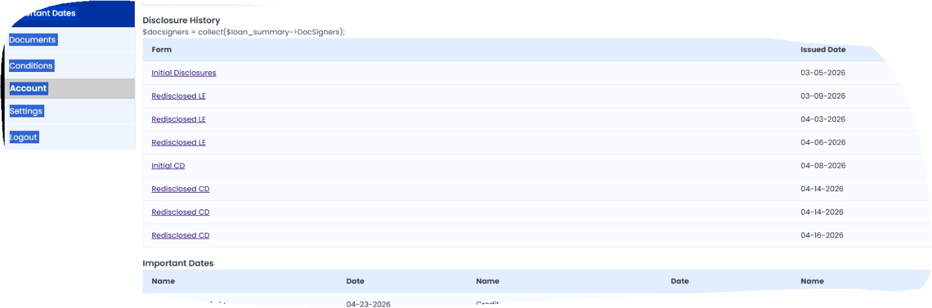

Ordering Appraisal

PLEASE read all below/see link on our NEW ineligible list (list has the AMCs and appraisers NOT to use) very important details/notes- This just recently changed

- IF this is an O/O or 2nd home so you cannot order the appraisal until AFTER your borrower acknowledges our ITP/initial disclosures

- IF this is a NOO loan, you can order the appraisal at any time as there is NO ITP/initial disclosures

- NOO property- regardless of loan program, we need a 1007 rent survey for 1 units and a 1025 rent survey for 2-4 units
- need the appraisal to be on COLOR and as a PDF & XML formats

- FOR NOO- you can order the appraisal from any AMC or directly through any licensed appraiser you want- but please make sure you scrub them to make sure they are NOT on our ineligible list

On a NOO DSCR deal OR a NOO DTI (full doc, bank statements), the broker can use any licensed appraiser if they are not on our ineligible list

They do not have to go through an AMC-but will need to use Mercury with Flanagan State Bank we are still in charge and responsible to order the appraisal and upload it to the ACRA GLIDE broker portal

We need the color PDF copy as well as the XML copy of the FULL appraisal

They just need to make sure they provide the appropriate verbiage, basically following USPAP, provide an air cert, etc…

OPTIONS below:

1. IF you already have an appraisal done, then please email me the AMC name & the appraisers full name & I will check them against our NEW ineligible list (below)

2. IF you have NOT ordered it yet, then YES please use ONE of the AMC’s below (IF you can)

3. IF you have NOT ordered it yet & you want to use your own AMC & appraiser, then send me BOTH the AMC’s name & the appraisers name & I will check them against our ineligible list

NEW AMC Appraisal process: IF you have not ordered the appraisal yet, then please order from 1 of these 5 AMC’s (IF you can)
The following 5 AMCs have confirmed they have our updated ineligible list.
Broker (you) must indicate Acra Lending as the lender so the appraiser can be scrubbed against our INELIGIBLE list.

- Consolidated Analytics- consolidatedanalytics.com
- Protec- now Stewart Valuations- 866 562 0123 (popular)
- Granite- www.GraniteRiskManagement.com
- Nationwide Property + Appraisal Services- 856 258 6977(popular)
- Class Valuation- 248 955 9580 (popular)

IF you want to check the ineligible list in GLIDE that we will not accept business from

- AMCs- SO CAL Direct and Fast App are just 2 of the many just added
- Appraisers
- escrow companies
- closers
- title companies
- notaries
- home insurance companies that we cannot accept policies from

In GLIDE, top right, please click on this link to view the list

OR

To be safe, please use one of the 5 AMCs on the list ABOVE in GLIDE- this is a list of AMCs that are already scrubbed against out do not accept list

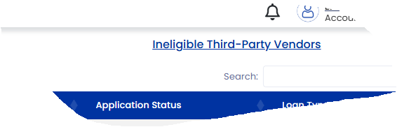

APPRAISAL REPORT FORMS

PROPERTY TYPE | FNMA FORM
SINGLE FAMILY RESIDENCE | URAR – Uniform Residential Appraisal Report  (FNMA Form 1004)
PLANNED UNIT DEVELOPMENT (PUD) | URAR – Uniform Residential Appraisal Report  (FNMA Form 1004)
CONDOMINIUM UNITS | Individual Condominium Unit Appraisal Report  (FNMA Form 1073)
SITE CONDOMINIUMS (DETACHED INDIVIDUAL CONDO UNIT) | Individual Condominium Unit Appraisal Report
MANUFACTURED HOMES | (FNMA Form 1004C)
2-4 FAMILY UNITS | Small Residential Income Appraisal Report  (FNMA Form 1025)

Once the file has been conditionally approved, suspended, or on hold and needing additional items

HOW to upload conditions on an APPROVED loan

- Go into GLIDE
https://alglide.com/ - GLIDE Broker Portal
- Go to your loan or loan #
- Go to conditions (top left)
then find the condition # that you want to upload to
- click on upload file
- upload the condition into the labeled folder

To pull up the most recent approval and UW worksheet

- Go to GLIDE
- Click on loan number
- Click on pipeline
- Click on loan number
- Click on documents
- Click view to open any document you want

NEW- OPTION IN GLIDE TO VIEW ALL CONDITIONS AND CLEARED CONDITIONS AND PENDING CONDITIONS

NEW now in GLIDE

Go to conditions (top left)

Then go top left hand side and see the conditions pending/cleared/all conditions

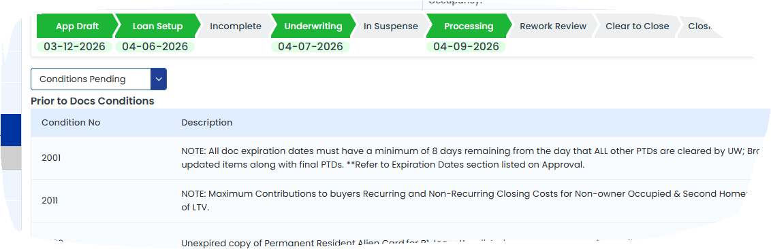

Updated approval attached that is in GLIDE as well

Please remember if you have not seen is the UW and Saleena have left some updated notes in GLIDE on any conditions that they have not cleared yet

Please go into GLIDE:

On each condition you can click on view docs to see what you have uploaded

Then IF it is NOT cleared, you can click on notes to see any updates from the UW or account manager on what is needed OR what is missing on that specific condition.
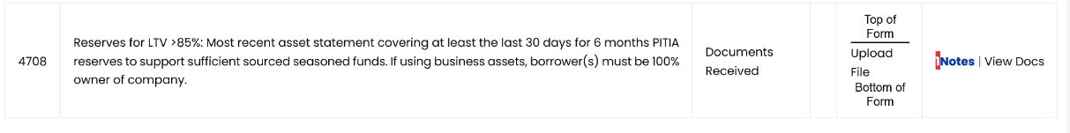

After you upload the conditions and the UW reviews the conditions, then you will get an email that says what conditions were cleared and you can also see IF a condition was NOT cleared, the UW will leave updated view notes or view docs on why it was not cleared and OR what is still needed to clear the condition

The conditions are on the hard copy approval & real time in GLIDE

CLEAR TO CLOSE:

Here is a brief snapshot of the steps after a CTC approval (could vary depending on IF wet state or dry state and the specific program- owner occupied or non-owner)- just a general overview

Once the file is transferred to the closing department it will take about 1-2 business day for the Acra closing department to initiate contact with the settlement agent to balance the file for docs out.
- ACRA will have an ACRA rep that is assigned to this loan that will work with the title/escrow/attorney

The ACRA doc/funder dept will work with the settlement agent/closer and balance the loan
- they will balance the loan together , set up all the impounds/prepaids and closing date and signing date/notary
- the ACRA doc rep will be working with our compliance dept to make sure items like this are taken care of and correct/complete
- Then the loan documents will be released once the file is balanced and the signing date is confirmed/set up
- You/broker will be included on all correspondence between the closing department and the settlement agent.

Please DO NOT SCHEDULE your closing in advance. The funder will confirm the closing date and time with the Settlement Agent.

Click on this link for our current posted turn times: Turn Times - Acra Lending

ADDITIONAL TUTORIALS
- How To Use Glide Income Desk
- How To Use Glide Pricing Quick Quote
- How To Use Glide Quick Application Tool
- How To Find PDF Approvals in Glide
- Where To Find Disclosures in Glide

Once the loan has been funded:
Update loan amount, income assets etc. in encompass, to match the final approval from the lender and then let APT know the file has funded.
Email: apt@flanaganstatebank.com
Title will need to mail the broker check- the address they will need to mail this to is:
Flanagan State Bank
Attention: Loan Servicing
P.O. Box 368 (needs to be listed for regular mail)
301 W. Falcon Hwy.
Flanagan, IL 61740

Mortgagee

CPL and Title’s loss payee should be – (used for Title work)
Citadel Servicing Corporation dba Acra Lending
ISAOA/ATIMA
3 Ada Parkway #200 A
Irvine, CA 92618
Loan number: See loan approval

HO6/HO3/Flood/Master Condo Policy’s loss payee should be –(used for insurance)
Citadel Servicing Corporation dba Acra Lending
ISAOA/ATIMA
PO Box 29411
Phoenix, AZ 85038-9411
Loan number: See loan approval

Turn Time: 45 to 60 days. You can request rushes if needed, but not guaranteed, contact the AE Assistant
- DSCR
- Bank Statements
- Profit and Loss

FOR DSCR LOANS- DO NOT PUT INCOME IN ON PAGE 2 IN ENCOMPASS, these loans do not use income to qualify. Make sure when ordering an appraisal, you will need a rent schedule.
FOR BANK STATEMENT OR PROFIT AND LOSS - use the income that had already been determined before starting this loan. (your LO should have done this part).

Please call, email or message me on teams if you need any help with anything. How to complete a step, understanding a condition, or a specific process.
We are considered the broker, and the APT investor is considered the lender.

