You have an alternative loan product and you and APT have determined what product and what lender…. What’s next:

When starting an APT loan

Step Number 1 – Initial Encompass Loan Setup:
- Before starting anything go to Easy Data Entry and complete the following:
  - Product Code
  - Investor Name
  - Once you are done entering this information please save the file. You will see that our rule base will setup the milestones to reflect the brokered loan process instead of a regular Agency loan automatically.

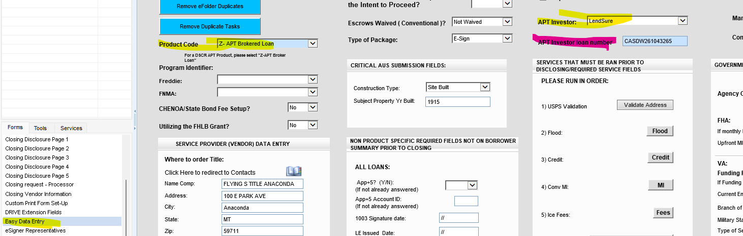
- Navigate to the Top Left of the Borrower’s Summary Origination Form within Encompass. If this field (2626) does not say broker, please reach out to MIT right away.

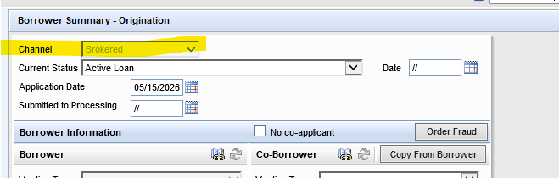
- Later you will get the investor loan number. Once you have started the file with the lender. Please enter it at that time!

- Once the loan is stated as a Brokered loan, you will NOT be able to send out disclosures or change the loan back to an agency loan product.

  - If later you want to do an Agency loan for the same applicants, you MUST start a whole new loan within Encompass. We suggest you use the export and import option. DO NOT duplicate the loan.
  - If after researching an APT loan and the applicants no longer qualify and you need to DENY the loan, remember that all brokered loan products must be denied under the “Prequal Denial” section on the denial form within Encompass. Please also remember to finish the application milestone for our Compliance team to receive that automated email. Brokered loans are NOT HMDA reportable, hence this policy.

Step Number 2 – Starting the APT Loan within Encompass once ready for Lender Submission:

Now enter the following information for processing and commission purposes.
- Now it is time to complete the URLA- TAKE A FULL APPLICATION-Make sure the info you are entering is correct This will save you or your processor time later throughout the process by being able to export the full application and import it to the lender’s website.
  - Except for HELOC loans, and ITIN (see notes below for these two types) you should be importing your credit report. You cannot determine if you have a potential qualified borrower without a credit report.
- Loan Amount
- Interest Rate
- Loan Term
- You can add more to the Easy Data Page that may help your processor later:
  - Title company
  - Homeowner’s insurance company
  - Notes to the processor

Step Number 3 – Preparing each loan for processing / Lender Submission:

This is also a good time to send out a borrower’s authorization for Flanagan State bank- the reason: the borrower will sign one with the lender that is being used, but that form will not let us order verifications and credit supplements. We need to have one with Flanagan State Bank in the file manager so the processor can process.

Most of the lenders will need our 1003 and/or a 3.4 (see below if lenders require specific information on the URLA- example, Lendsure requires subject address to be listed as TBD for a purchase file -you can add address once you have created your 3.4 file-see below), if the file is a DSCR, you won’t add income on page 2, bank statement or P&L loans, add the income that has been determined by the chosen lender during the prequalification stage) -

Steps for Creating the 3.4
Once your file is ready to create a 3.4 here are the steps-
- Exit your file and go to your pipeline view.
- Rt click on the loan
- Scroll to GSE Services
- Go to ULAD (DU MISMO 3.4) or the iLad (MISMO 3.4) this will be noted on the specific lender instructions.
- Download and save it to your desktop, this will be sent once ready


Heloc –With REMN, they will pull a soft pull themselves, but it’s a good idea to have your own. Forward Lending also requires just a soft pull, this can be pulled by the LO or the Forward Lending.
ITIN-The lender will pull their own report – TRANSUNION only, but it’s also a good idea to do a soft pull for Transunion yourself as well.

Forward Lending Processing Guide

Account Setup
Need Portal Access?
APT can assist with obtaining your Forward Lending login credentials.
Contact:
- Email: tdavis@mtgbyallison.com
- Phone: 765-413-8806

Account Executive
Lloyd Hopkins
- Phone: 734-637-4353
- Email: lhopkins@forwardlendingmtg.com
Account Manager
Jose Soberanes
- Phone: Direct: 949-393-7462 Cell: 310-431-6145
- Email: VGomez@ForwardLendingMTG.com

FHA Lender ID: 2099600001 / VA Lender ID: 169917-0000

Broker Portal
Login: https://forwardlendingmtg.com/
Once here, go to Submit, and the Track TPO Portal, to log in -a code will be sent to your email
You will see this when you log in
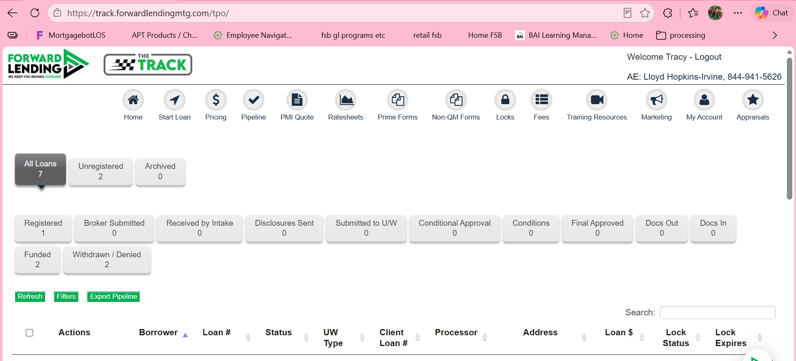

Step 1. To start a loan,
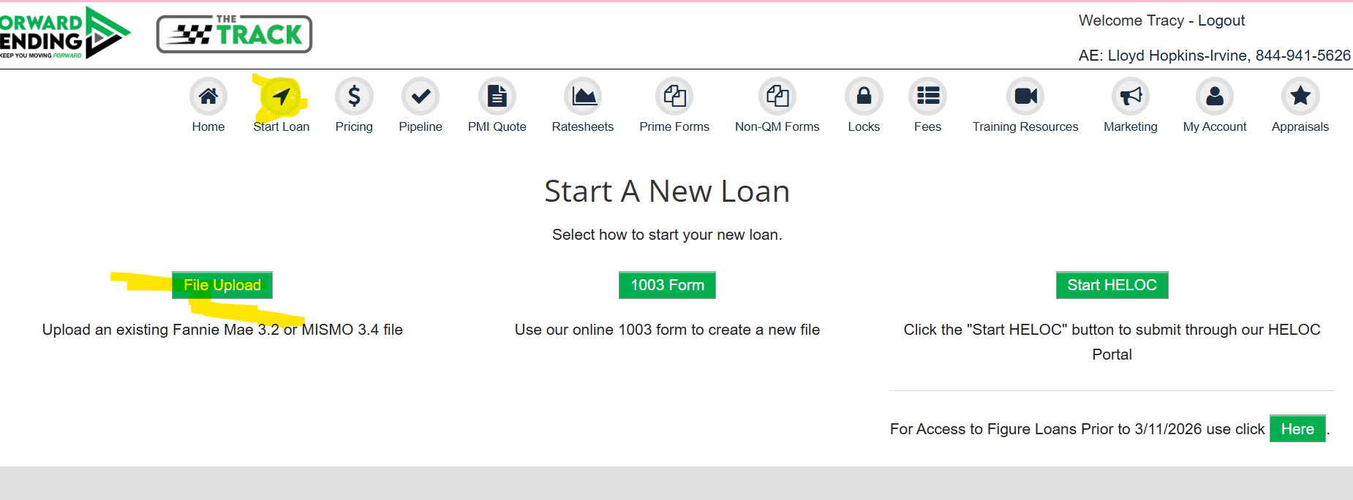
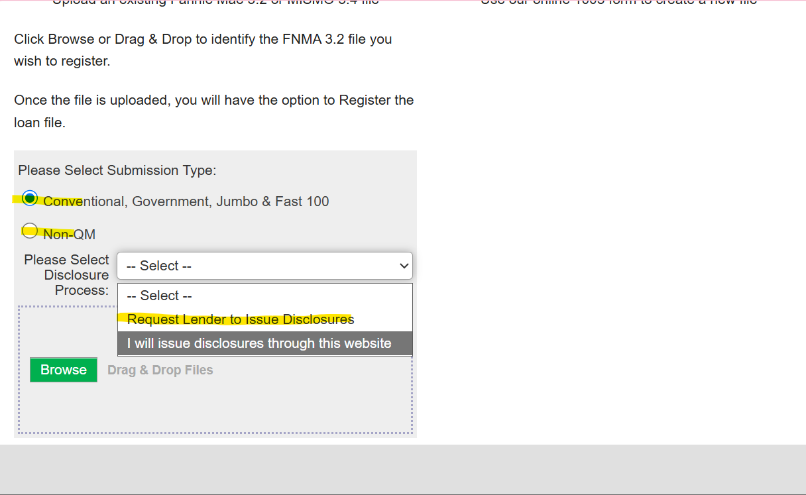
After downloading the 3.2 file, scroll to the bottom and click validate, and correct anything that needs to be corrected
Then click on register loan (you will be able to upload your credit later)
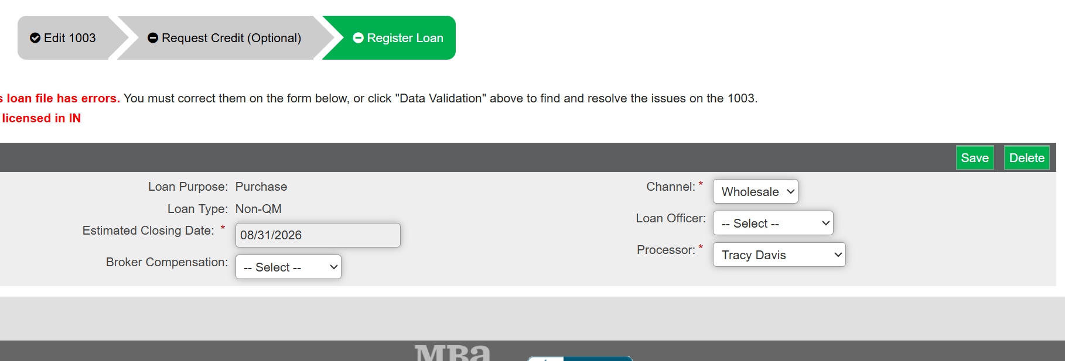
If there are errors you will not be able to continue,
Be sure to mark the broker compensation as borrower paid, pick your LO and make sure to select you as the LO then click save. The system will review for duplicate loans, once its done that, you can click register.
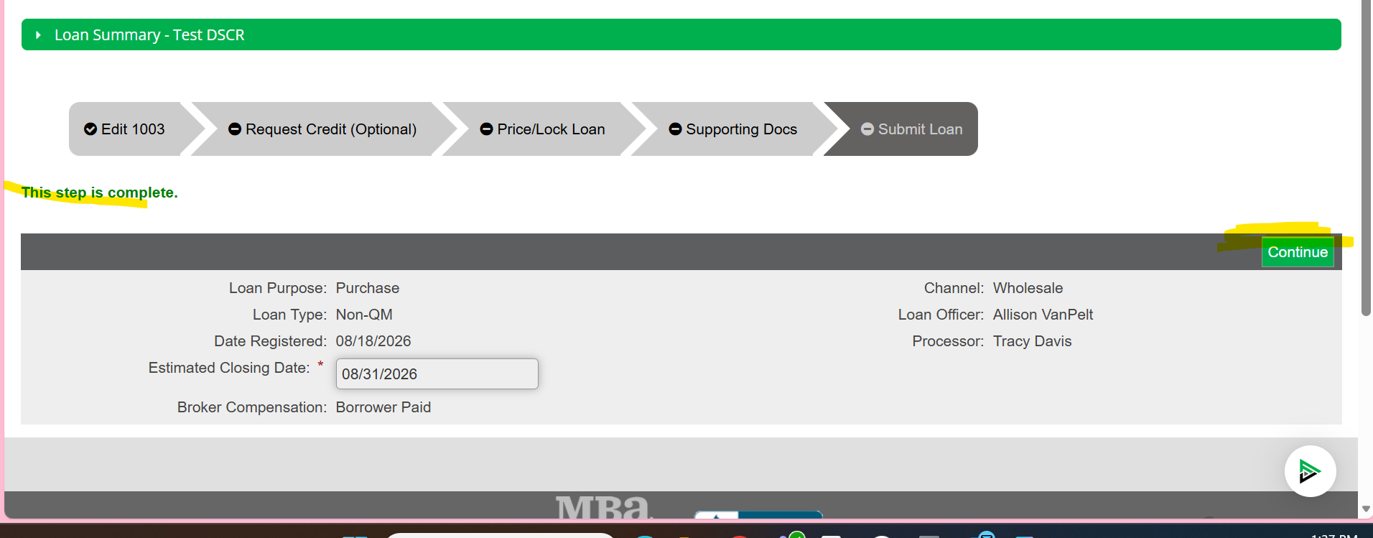
Click continue

Go to price/lock loan
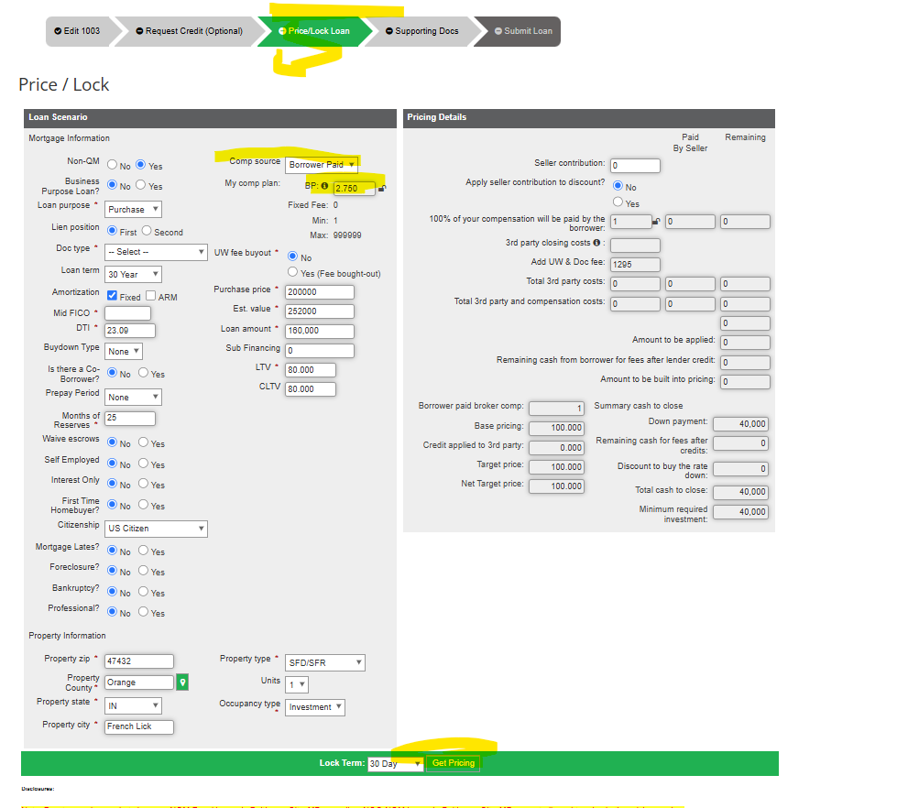
Comp source--Borrower paid- you will be adding the broker fee to the cost, so in the example below, 7.99 is par rate, so there isn’t any cost for that rate, but the 2.75% will be added, to the itemization and the borrower will pay for this. Lender paid, the fee will be included in the pricing, anything under par will be charged to the borrower.
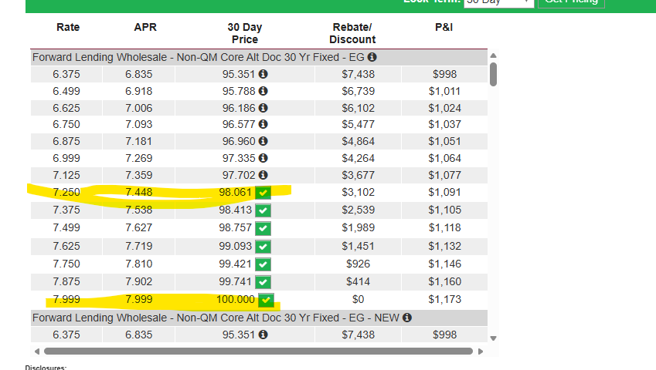
Click lock or float
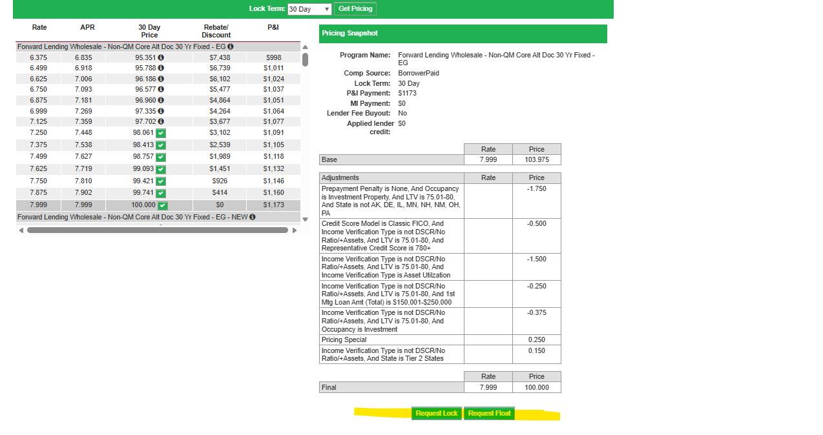
Step 2. Next step go to supporting documents
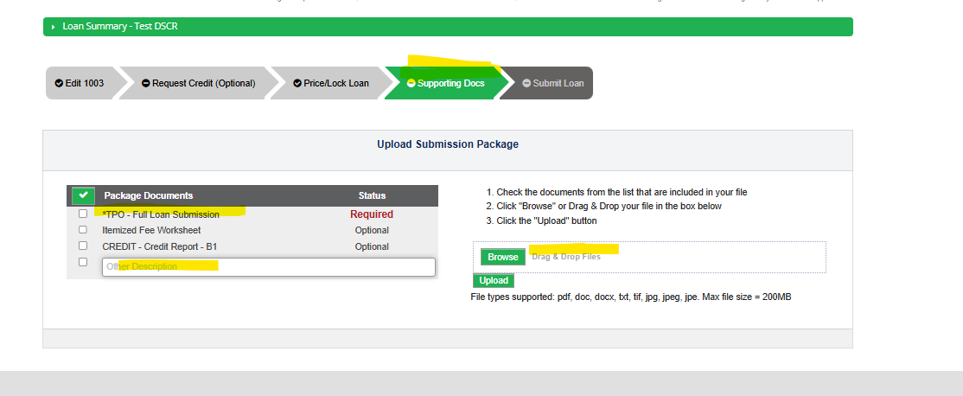
Here is where you can add all of your documents, depending on the loan program, you can also upload your credit report here. You will also complete a loan submission form and upload that at this time. (see attached). Disclosures will be sent out

Once you have started the loan, the file will show up in your home page
This file was just a test file so it was not submitted
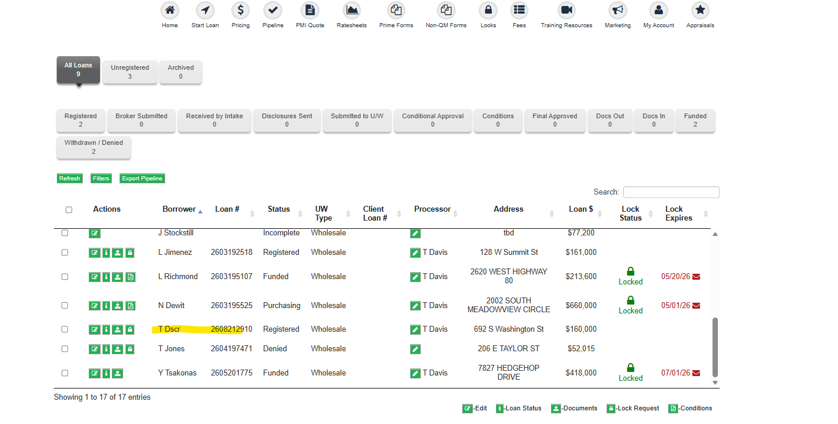

The Account manager will get the file disclosed and ready to submit to UW for the initial conditional approval. The more you upload prior to pushing the submission folder the cleaner your approval will be. TIPS-when uploading bank statements for loans that require them label each statement- label paystub dates, keep things clean and organized. After you upload, someone on the other side is moving everything into an encompass file. That is what the UW’s are using. We don’t see that side.

APPRAISAL
Once disclosed and when you are ready to order the appraisal, you will click on your loan from the home page and then click on order appraisal. You need to be set up with an AMC. There will be a list of AMCs to pick from. Once you are set up you can place your order.

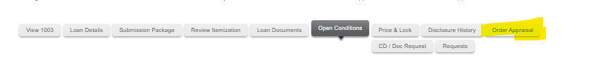
Step 3. Submitting conditions
Once the file has been underwritten, you will be sent an email with the approval attached,
Log into the website and go to your loan. Click on conditions
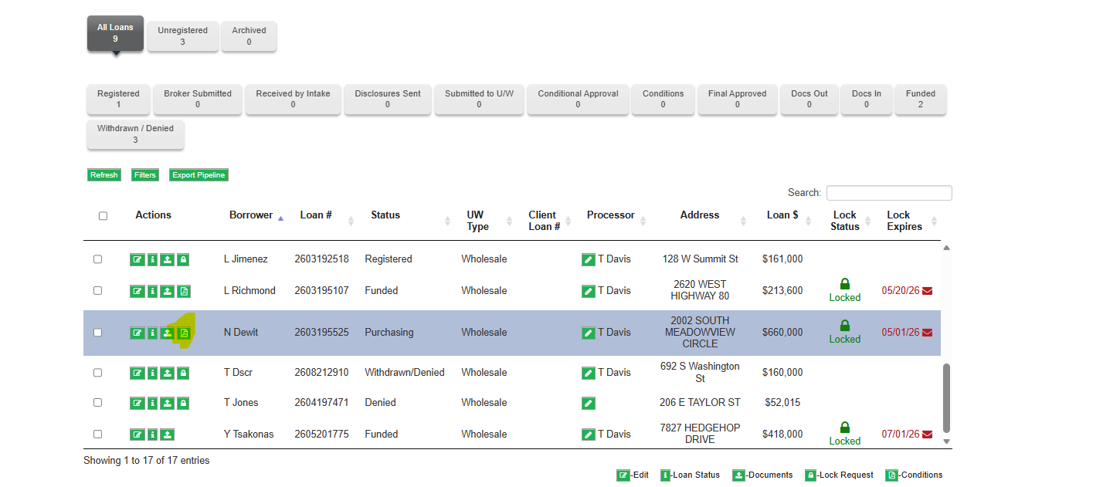
You can then review your loan summary; make sure it matches what you have in encompass with Flanagan State Bank. This will help you if you and the UW are not agreeing on income, assets, debts, etc.
Go to open conditions
You will want to gather all the items needed prior to documents and approval, you can search with all conditions, or you can pull up only the ones you want, prior to documents or prior to approval, you can upload conditions, or you can drag and drop.
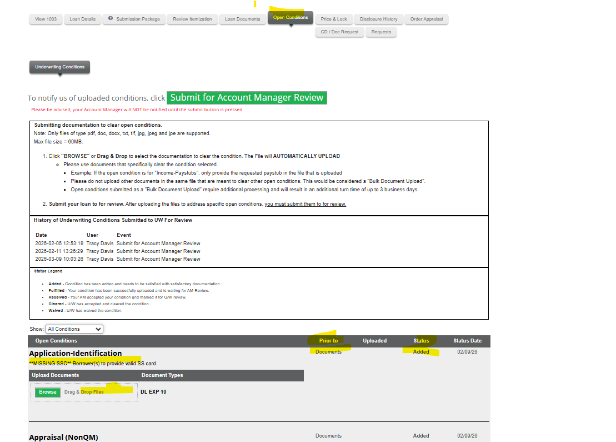
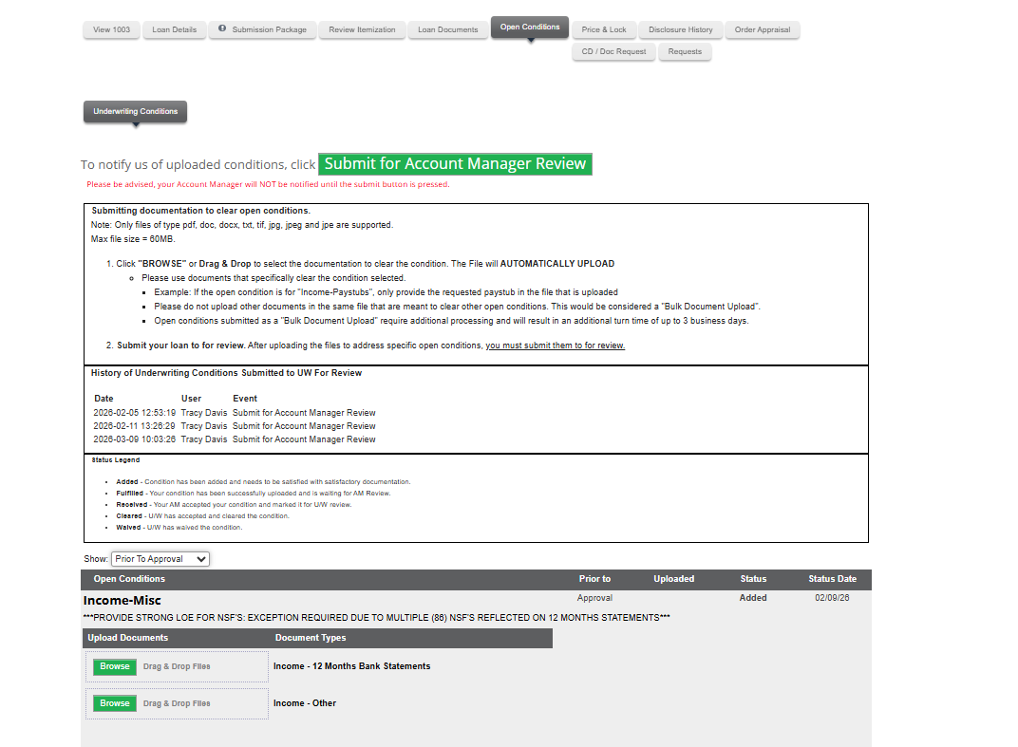
When documents are added to a condition you will see this
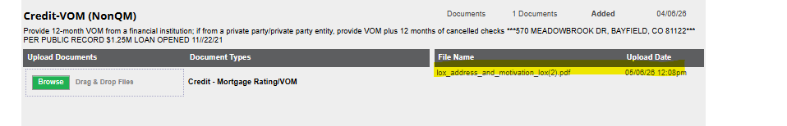
Once you have all your conditions, you will need to click the green button Submit to Account Manager Review. When they feel there is enough to send to the underwriter, they will send. If they want more before sending them to UW, they will send you an email
Step 4. Closing
When you are ready for your Cd to go out, click on the CD/Doc Request tab and complete each step but be sure to email your Account Manager once the CD request button is completed, just so they are aware. Some Account Managers may ask you to email items directly, every AM is different. Ask your Account Manager which way they prefer.
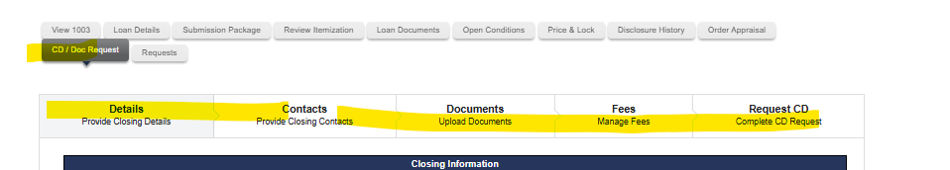
Once the underwriter is completed with the file it will go to QC, it could be here for a couple of days, plan for 48 hours. They may come back and ask for additional items, once they are satisfied, they will clear the file to close and start balancing with title. You can usually close within 48 hours after the clear to close.
NOTE- ONCE BALANCED, CHECK YOUR FINAL CASH TO CLOSE WITH WHAT HAS BEEN APPROVED ON THE APPROVAL. AND REVIEW ANY OTHER FUNDING CONDITIONS.

*BANK STATEMENT LOANS AND DSCR LOANS – The borrowers will get a link sent to them prior to ctc, this is to verify the bank statements. The borrower will need to log in using their banking login.

The Extras
The request button is for COC and to extend rates
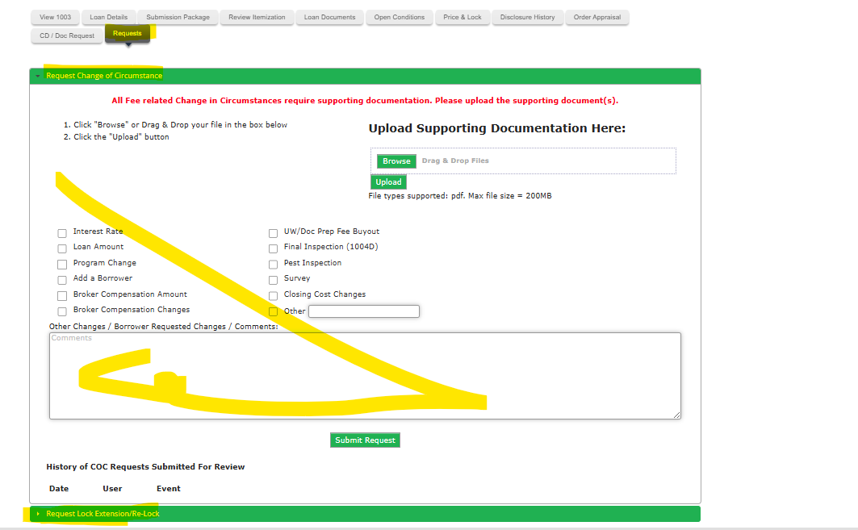
When wanting to lock, click on Price & Lock
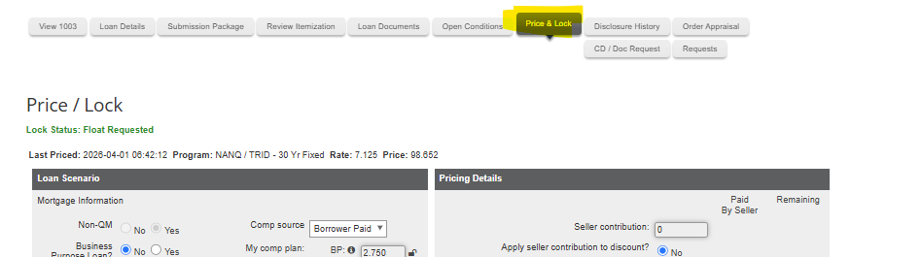
If you want to review documents that have been uploaded, click on the button Loan Documents
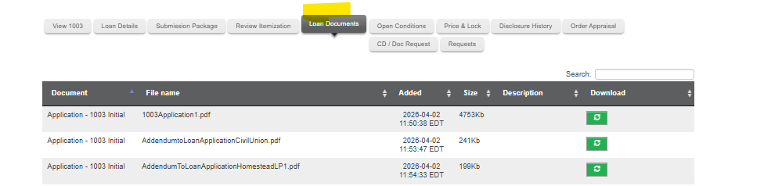

Once the loan has been funded:
Update loan amount, income assets etc. in encompass, to match the final approval from the lender and then let APT know the file has funded.
Email: apt@flanaganstatebank.com
Title will need to mail the broker check- the address they will need to mail this to is:
Flanagan State Bank
Attention: Loan Servicing
P.O. Box 368 (needs to be listed for regular mail)
301 W. Falcon Hwy.
Flanagan, IL 61740

Mortgagee Clause: for title and insurance for Forward Lending
OCMBC, Inc. ISAOA/19000 MacArthur Blvd., Suite 200 Irvine, CA 92612

FHA Lender ID: 2099600001 / VA Lender ID: 169917-0000

Turn Time: 45 to 60 days. You can request rushes if needed, but not guaranteed, contact the AE Assistant.

Loan Products
Forward Lending offers:
- DSCR
- Bank Statements
- Profit and Loss
- Jumbo
- Traditional conventional and government loans

FOR DSCR LOANS- DO NOT PUT INCOME IN ON PAGE 2 IN ENCOMPASS, these loans do not use income to qualify. Make sure when ordering an appraisal, you will need a rent schedule.
FOR BANK STATEMENT OR PROFIT AND LOSS - use the income that had already been determined before starting this loan. (your LO should have done this part).

For additional information
Home | Track Support Help Center

Please call, email or message me on teams if you need any help with anything. How to complete a step, understanding a condition, or a specific process.
We are considered the broker, and the APT investor is considered the lender.

