You have an alternative loan product and you and APT have determined what product and what lender…. What’s next:

When starting an APT loan

Step Number 1 – Initial Encompass Loan Setup:
- Before starting anything go to Easy Data Entry and complete the following:
  - Product Code
  - Investor Name
  - Once you have done entering this information please save the file. You will see that our rule base will setup the milestones to reflect the brokered loan process instead of a regular Agency loan automatically.

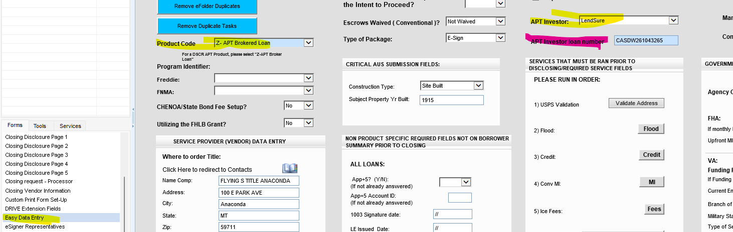
- Navigate to the Top Left of the Borrower’s Summary Origination Form within Encompass. If this field (2626) does not say broker, please reach out to MIT right away.

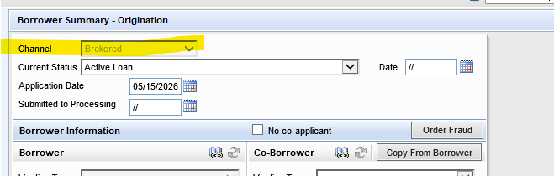
- Later you will get the investor loan number. Once you have started the file with the lender. Please enter it at that time!

- Once the loan is stated as a Brokered loan, you will NOT be able to send out disclosures or change the loan back to an agency loan product.

  - If later you want to do an Agency loan for the same applicants, you MUST start a whole new loan within Encompass. We suggest you use the export and import option. DO NOT duplicate the loan.
  - If after researching an APT loan and the applicants no longer qualify and you need to DENY the loan, remember that all brokered loan products must be denied under the “Prequal Denial” section on the denial form within Encompass. Please also remember to finish the application milestone for our Compliance team to receive that automated email. Brokered loans are NOT HMDA reportable, hence this policy.

Step Number 2 – Starting the APT Loan within Encompass once ready for Lender Submission:

Now enter the following information for processing and commission purposes.
- Now it is time to complete the URLA- TAKE A FULL APPLICATION-Make sure the info you are entering is correct This will save you or your processor time later throughout the process by being able to export the full application and import it to the lender’s website.
  - Except for HELOC loans, and ITIN (see notes below for these two types) you should be importing your credit report. You cannot determine if you have a potential qualified borrower without a credit report.
- Loan Amount
- Interest Rate
- Loan Term
- You can add more to the Easy Data Page that may help your processor later:
  - Title company
  - Homeowner’s insurance company
  - Notes to the processor

Step Number 3 – Preparing each loan for processing / Lender Submission:

That is also a good time to send out a borrower’s authorization for Flanagan State bank- the reason: the borrower will sign one with the lender that is being used, but that form will not let us order verifications and credit supplements. We need to have one with Flanagan State Bank in the file manager so the processor can process.

Most of the lenders will need our 1003 and/or a 3.4 (see below if lenders require specific information on the URLA- example, Lendsure requires subject address to be listed as TBD for a purchase file -you can add address once you have created your 3.4 file-see below), if the file is a DSCR, you won’t add income on page 2, bank statement or P&L loans, add the income that has been determined by the chosen lender during the prequalification stage) -

Steps for Creating the 3.4
Once your file is ready to create a 3.4 here are the steps-
- Exit your file and go to your pipeline view.
- Rt click on the loan
- Scroll to GSE Services
- Go to ULAD (DU MISMO 3.4) or the iLad (MISMO 3.4) this will be noted on the specific lender instructions.
- Download and save it to your desktop, this will be sent once ready
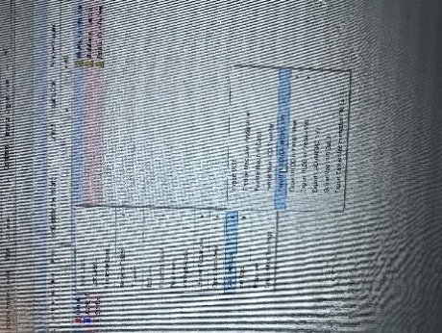

Helix –With REMN, they will pull a soft pull themselves, but it’s a good idea to have your own. Forward Lending also requires just a soft pull; this can be pulled by the LO or the Forward Lending.
ITIN-The lender will pull their own report – TRANSUNION only, but it’s also a good idea to do a soft pull for Transunion yourself as well.

REMN Processing Guide
Account Setup
Need Portal Access?
APT can assist with obtaining your REMN login credentials.

Contact:
- Email: tdavis@mtgbyallison.com
- Phone: 765-413-8806

Account Executive: Julie Aceto
- P: (630)699-4116
- E: jaceto@remn.com

Before you are ready to start the loan, the LO may want to price it - log onto the website Portal
Click on tools, 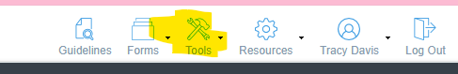 this will open a new box that you can click on hyperlinks to get current pricing. If you have questions at any point you can click on the little bubble on the bottom right-hand corner, 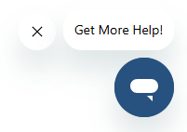 They stress using this tool for help.

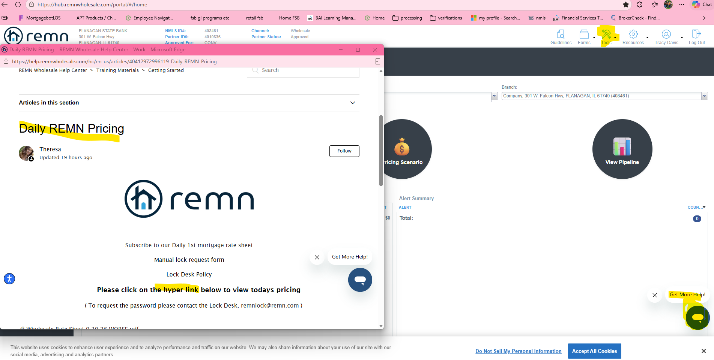
You can get pricing here also
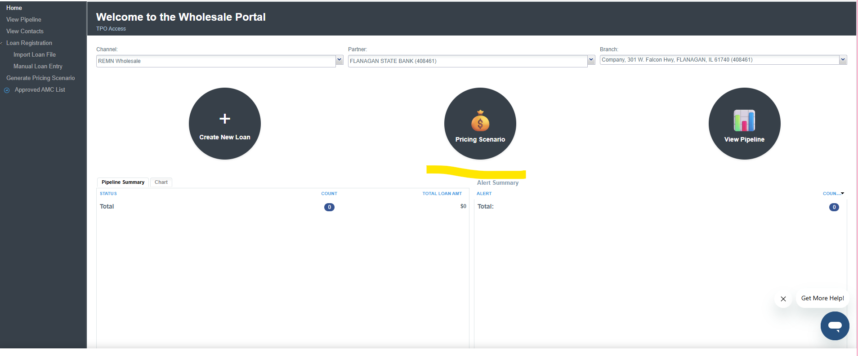
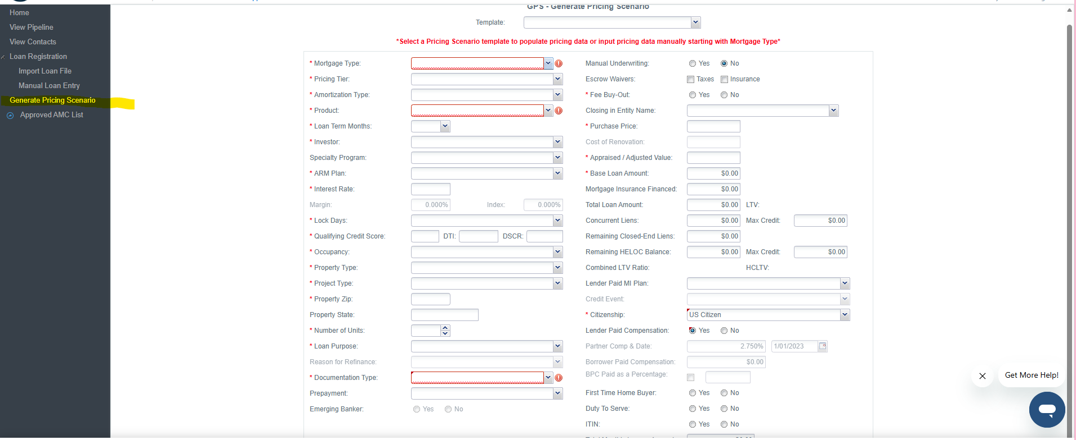

Now you are ready to start the loan-
There are three ways to register a loan in the REMN Broker Portal.

- Import a MISMO 3.4 file (.xml)
- Import an AUS file already assigned to REMN, or
- Manually enter the information into the system.
Import FNMA 3.4 file
Step | Action
1 | From the home screen select Import Loan File under Loan Registration.  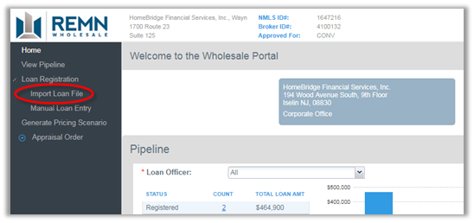

2 | Select MISMO 3.4 Submission and click the Browse button to navigate to the 3.4 file.  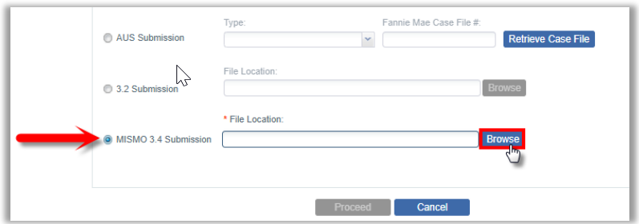

3 | Double-click the .xml file.  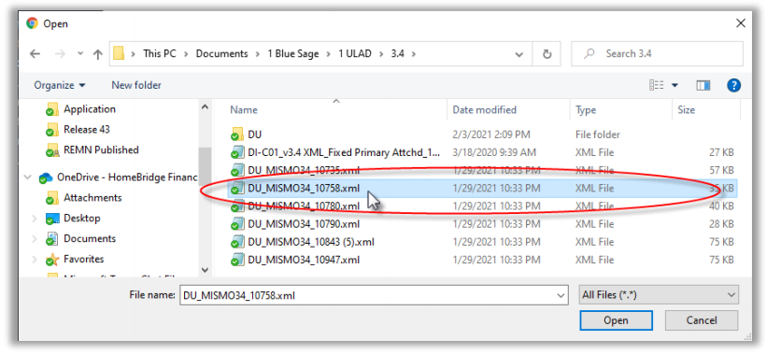

4 | Click Proceed to pull the loan information into the HUB.  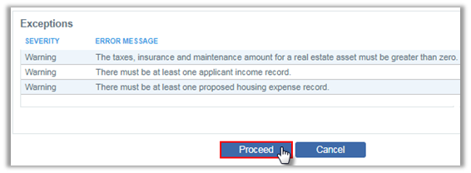  Helpful Tip: The Exceptions section will warn of any issues with a detailed Error Message. These warnings are informational and will not stop you from proceeding with the file.

5 | Review the fields in the order they appear for any missing or incorrect information. The dropdown lists are dependent on the information entered earlier on the screen.  · All required information is indicated by a *  · Missing required information indicated by   · User changed information is marked by red indicator in the corner of the field.  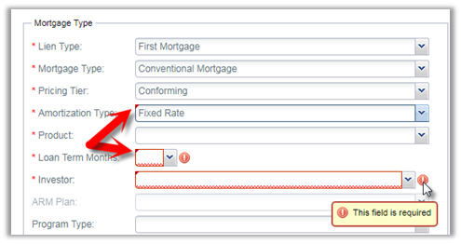  Helpful Tip: You will need to manually enter the Loan Application Date, Settlement Date, and the Qualifying Credit Score

6 | Click Register at the bottom of the screen.  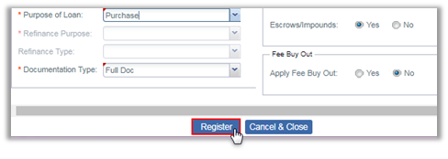

7 | A pop up message will display the Loan Number and confirm the Registration.  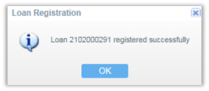

Add this loan number to encompass on the Easy Data Entry Page 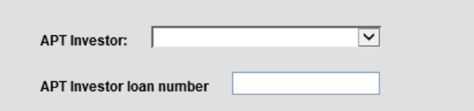.

Import AUS Findings
Step | Action
1 | To retrieve AUS findings that are assigned to REMN, select Import Loan File under Loan Registration.  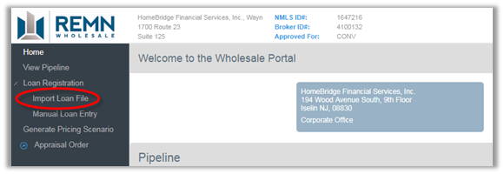

2 | · Select AUS Submission.  · Choose Desktop Underwriter or Desktop Underwriter MISMO 3.4, or Loan Product Advisor in the dropdown.  · Enter the 10-digit Case #.  · Click the Retrieve Case File button.  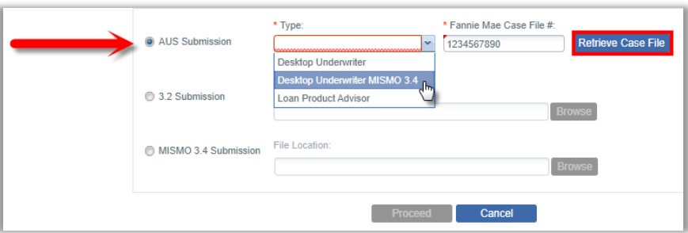

3 | Click Proceed to pull the .fnm information into the Broker Portal.  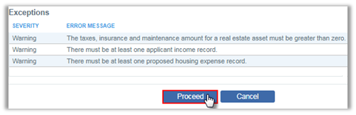  Helpful Tip: The Exceptions section will warn of any issues with a detailed Error Message. These warnings are informational and will not stop you from proceeding with the file.

4 | Review the fields in the order they appear for any missing or incorrect information. The dropdown lists are dependent on the information entered earlier on the screen.  · All required information is indicated by a *  · Missing required information indicated by a  · User changed information is marked by red indicator in the corner of the field.  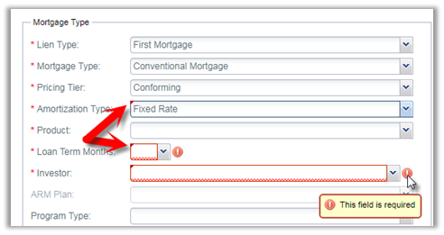

5 | Click Register at the bottom of the screen.  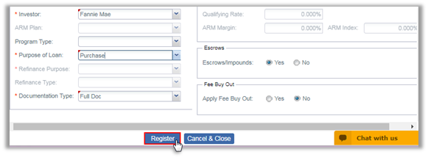

6 | A pop up message will display the Loan Number and confirm the Registration.  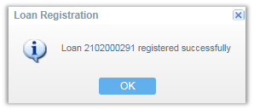

Manual Loan Entry
Step | Action
1 | To manually enter a loan for Registration, click Manual Loan Entry in the menu under Loan Registration.  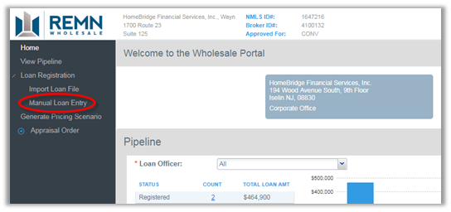

2 | · Enter the fields in the order they appear. The drop down lists are dependent on the information entered earlier on the screen.  · Enter all the * required fields.  · Use the dropdown list to select options.  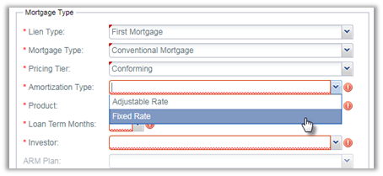

3 | Click Register at the bottom of the screen.

4 | A pop up message will display the Loan Number and confirm the Registration.

Forms:
If you are required to have specific lender forms, you can find them on the website- General Forms - REMN Wholesale - A Division of Homebridge Financial Services
Products - REMN Wholesale - A Division of Homebridge Financial Services
Disclosures - REMN Wholesale - A Division of Homebridge Financial Services
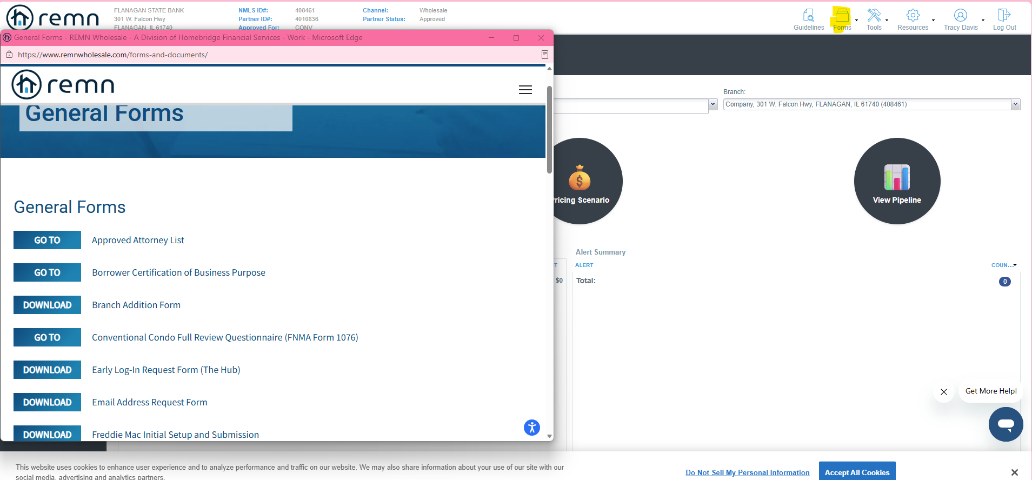

Ordering appraisals-
You will need to order form their list of AMC’s Vendors/Agencies - REMN Wholesale - A Division of Homebridge Financial Services
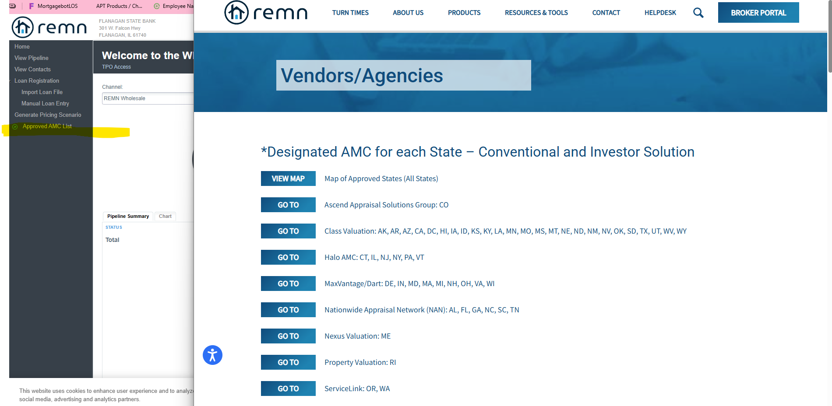

There are different AMC’s depending on the loan product, continue to scroll until you find the product you are needing.
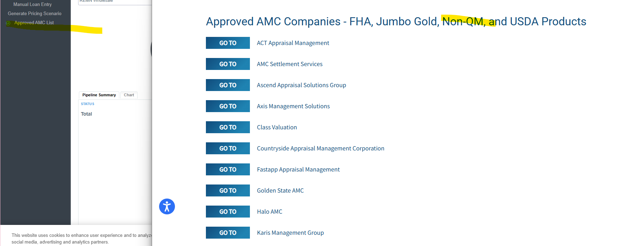
If the file was with another lender-example uwm -the AE could get an exception to transfer it to REMN
If you want to review the guidelines for a specific product, go here: Products - REMN Wholesale - A Division of Homebridge Financial Services
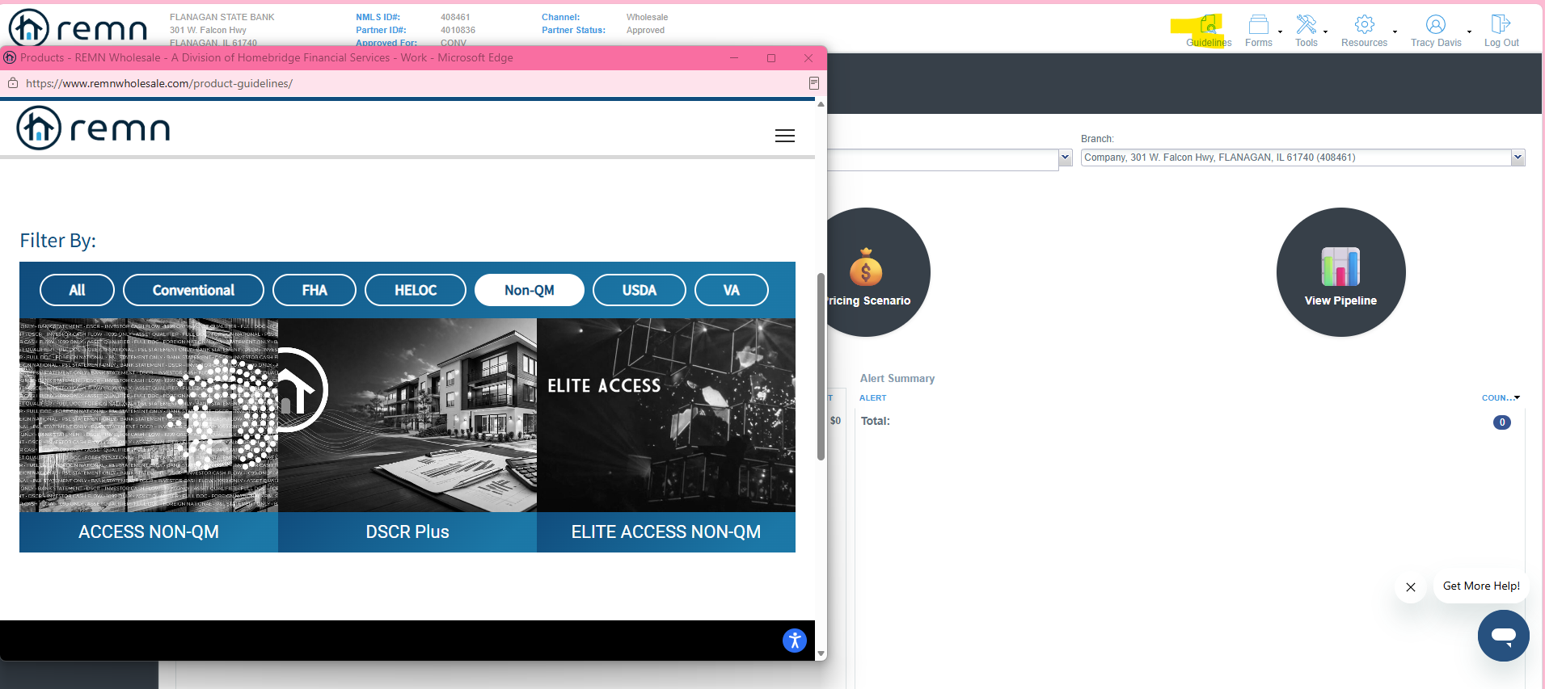

Mortgagee for Homeowners and flood insurance:
ServiceMac, LLC ISAOA ATIMA
PO Box 29411
Phoenix, AZ 85038-9411

Mortgagee for Title and CPL:

Homebridge Financial Services, Inc. DBA Real Estate Mortgage Network
ISAOA/ATIMA
99 Wood Avenue South Suite 301
Iselin, NJ 08830

Once the loan has been funded:
Update loan amount, income assets etc. in encompass, to match the final approval from the lender and then let APT know the file has funded.
Email: apt@flanaganstatebank.com
Title will need to mail the broker check- the address they will need to mail this to is:
Flanagan State Bank
Attention: Loan Servicing
P.O. Box 368 (needs to be listed for regular mail)
301 W. Falcon Hwy.
Flanagan, IL 61740
FOR DSCR LOANS- DO NOT PUT INCOME IN ON PAGE 2 IN ENCOMPASS, these loans do not use income to qualify. Make sure when ordering an appraisal, you will need a rent schedule.
FOR BANK STATEMENT OR PROFIT AND LOSS - use the income that had already been determined before starting this loan. (your LO should have done this part).

Please call, email or message me on teams if you need any help with anything. How to complete a step, understanding a condition, or a specific process.
We are considered the broker, and the APT investor is considered the lender.

