Encompass – Processor USDA Household Income and Certification

Completing the USDA Household Income
On all USDA loans, the processor will be responsible for filling out the USDA Income Disclosure and then sending it to the borrower(s) along with an income certification disclosure. Below are the steps to handle that task.:

Step #1: Go to the USDA Management form within each USDA loan!
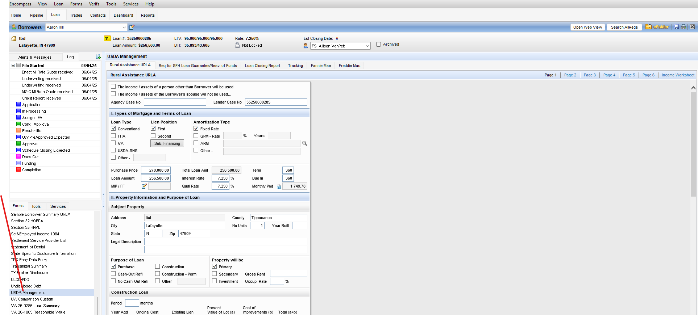

Step #2: Go to the Income Page
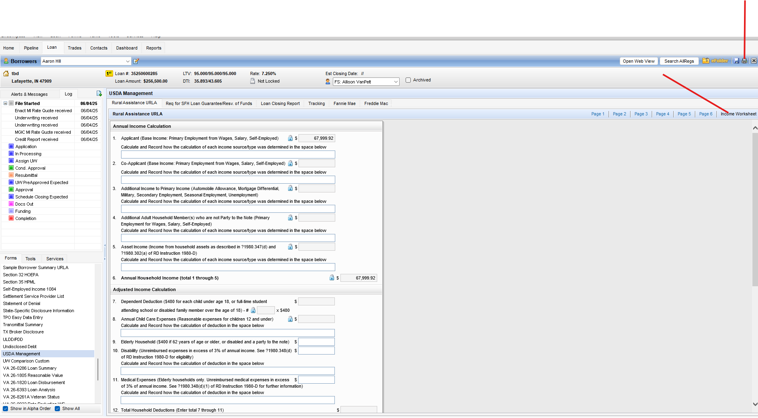
From this page simply hit your “Printer” icon and the print form will pull up automatically!
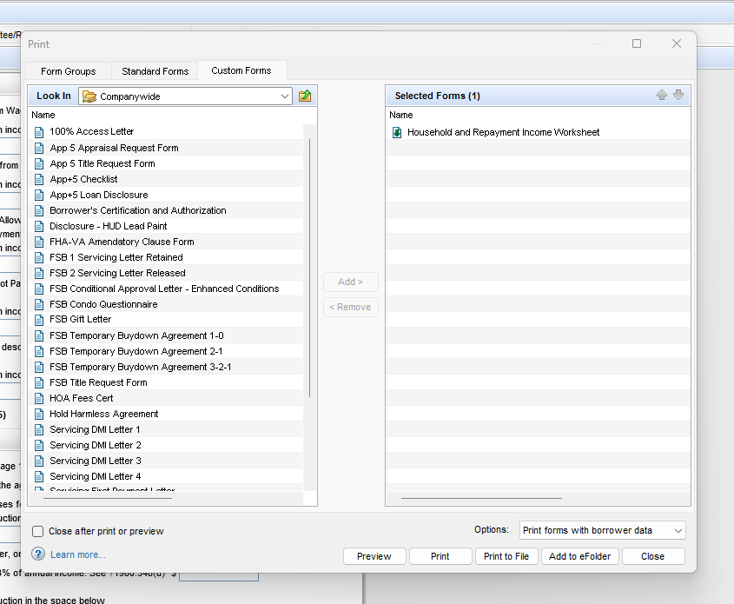

Step # 3: Add from the “Custom Print Form” library the USDA Certification form:

