SETTING UP BONAFIDE DISCOUNT POINTS WITHIN ENCOMPASS

Discount Point Setup:
Simply go to the ATR QM Management Form:
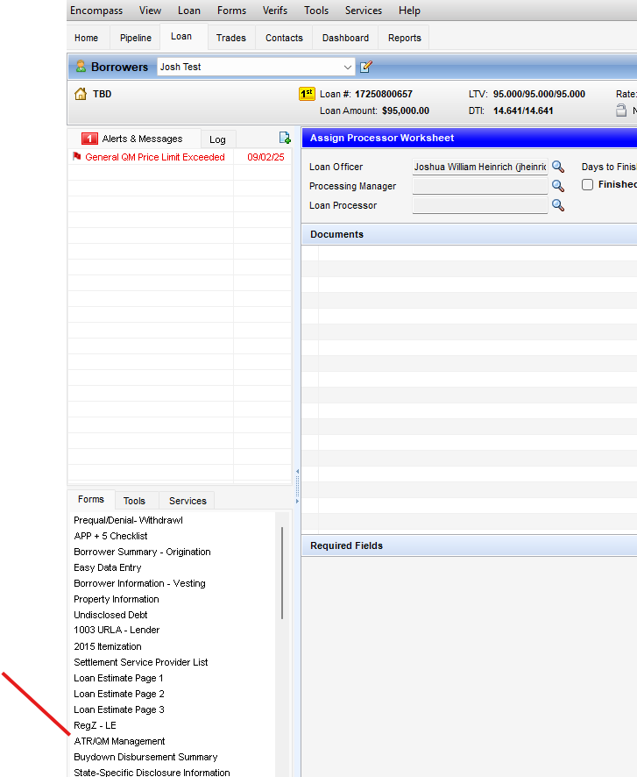

Then make sure to go to the “Qualification” tab and enter the highest rate available from ICE PPE pricing engine under BOTH the Starting Adjusted rate, and the Undiscounted rate fields.
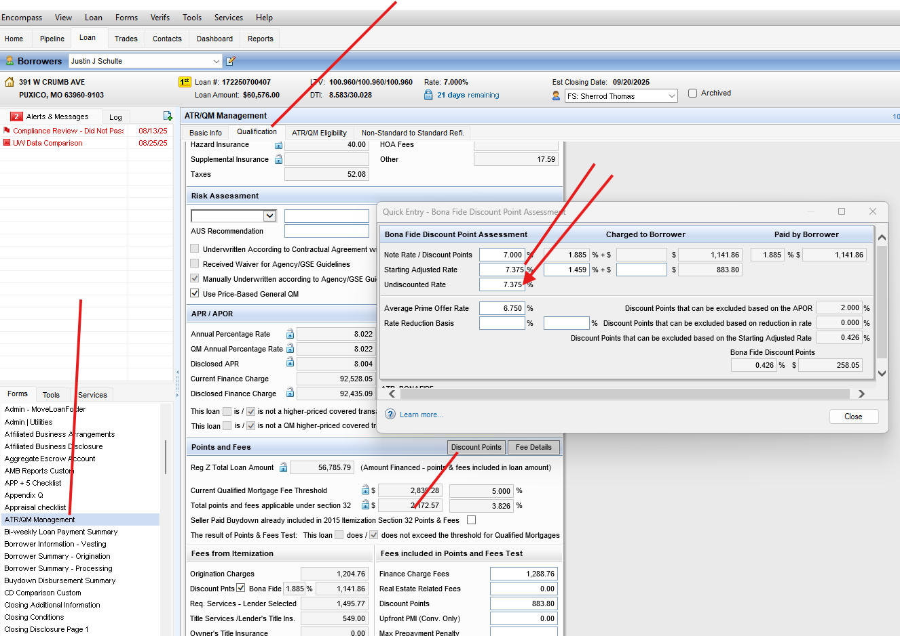
If you still need to remove some discount and would like not to, you may itemize a seller credit if applicable directly on the Discount Line Item 802 on the 2015 Itemization Form. However, this may ONLY be used with a “Specific Seller Credit” as listed on the sales contract (PA).
