Encompass – closing information and ordering docs
Click Pipeline Tab – top left corner
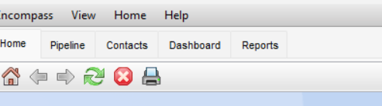
Double click on file to work on
Click on top row “Loans” and click on “Apply Input Form Set Template”
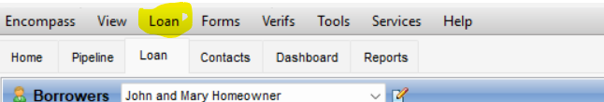

Click on #4 – Closing Form List

- Start with Borrower Information Vesting – on the left in the list
Click on each borrower name in the Vesting information box
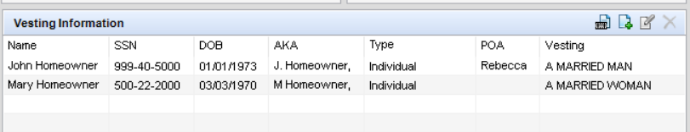
check the info in the pop up box
- List any AKA’s and separate by a comma, semi colon, etc. however you separate them is how they will show on the documents
- The occupancy status pull through, however the occupancy intent does not, click the drop down box and check which one applies
- If in a trust, click the drop down box and check which one applies for trustee 1 or 2
- If POA, only type in the name of the POA as the system will automatically pull the right verbiage for the state. You can override this by filling in POA Signature Text
- Input Vesting by clicking the drop down box and choosing which one
- Click ok
- Process the co-borrower the same way
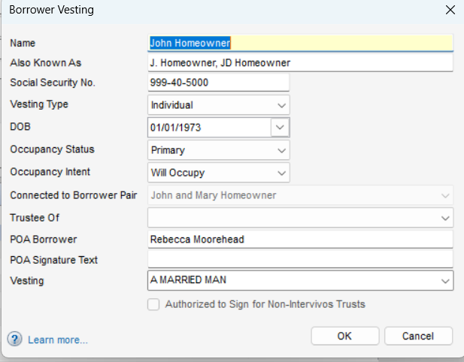

OR You can do the manner in which Title will be held, click the drop down box and choose.
Once completed “build final vesting”, once you click this, it will show you how the vesting will read on the documents and this is editable in the box if necessary
You can see the vesting had “a married man” and “ a married woman” and the title was marked “joint tenancy with right of survivorship” – you usually don’t want both.
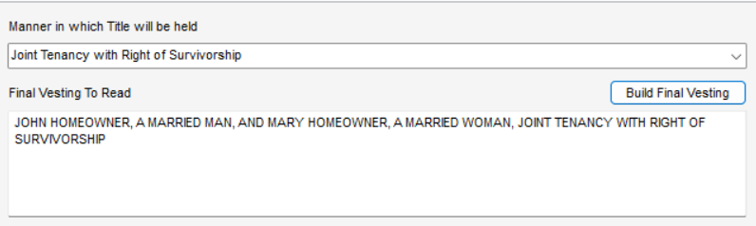
The Seller info should pull through from the file contact. If you need to add something you need to do that in file contacts under tools on the left
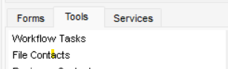
Click file contacts and a list of contacts for the file will show up. This is where you can edit a contact’s information or add a contact – click on the box in the upper right corner
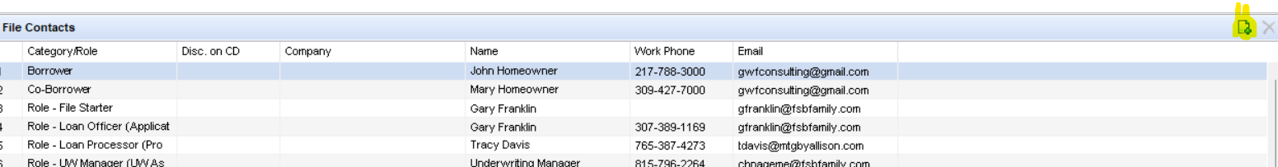
This is where you would add a Non Borrower spouse/owner and pick vesting type
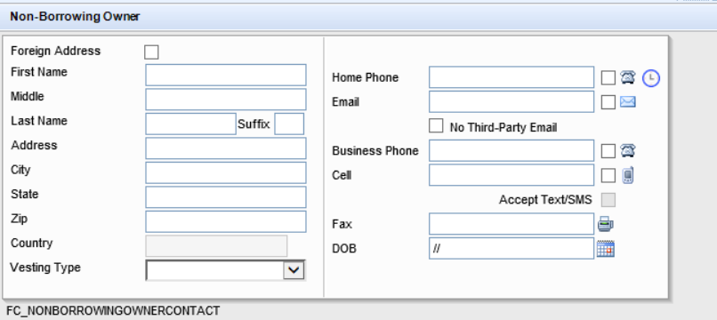
- Closing Vendor Information – click on this.
There are 3 required sections to be completed
Lender Info – which should pull through automatically
Title Insurance Company – which should pull through automatically
Docs prepared by – which should pull through automatically
Double check the info to insure it is correct
Add any other vendors that are necessary.
Under Title Insurance Company – if the Escrow Company is different from the Title Company you will need to fill that in.
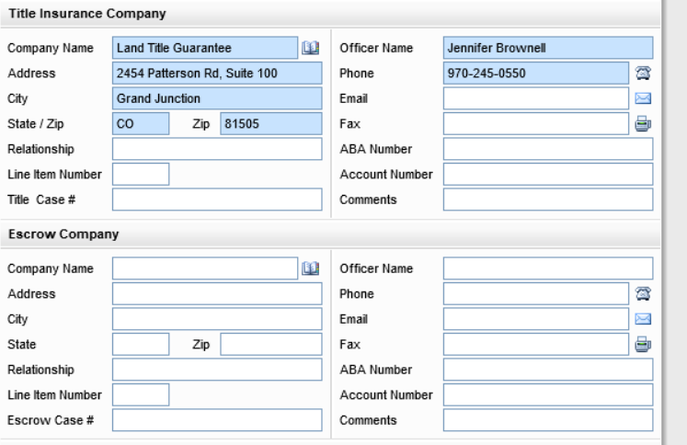
The Trustee Section is for the Deed of Trust States and if the title company is the trustee the system will automatically pull in the information for that state.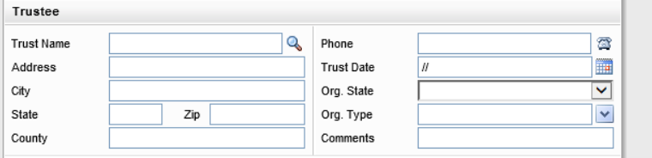
- Click on Property Information
Verify the information – if property is a Condo/PUD you will need to fill in the information on that.
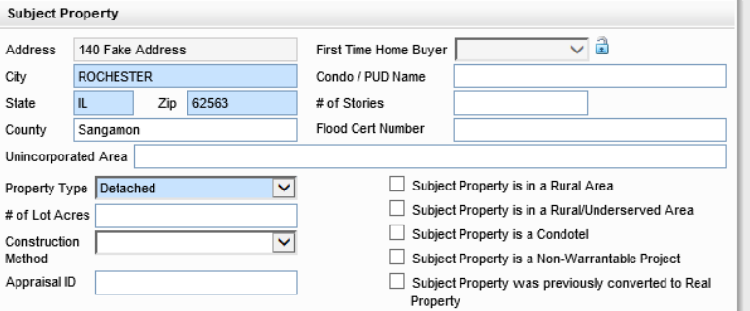

The flood section should automatically populate from pulling the flood through Encompass.
The mailing address should pull from the URLA, double check to see if investment property and if so you may need to change the mailing address
The title information shows on the Tax Information Form
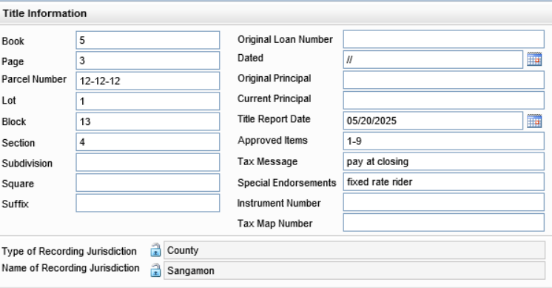

Original Loan Number is for a Flanagan State Bank loan only if we are doing a refi of a Flanagan State Bank loan.
Title Report Date should be the date of the latest title commitment
Approved items would be the items approved on the title commitment and shows up on the closing instructions
Tax message – put in any information about the taxes, ie. Pay taxes at closing, pay 2nd installment at closing, etc.
Special endorsements – is a message to closing agent on endorsements – ie, fixed rate rider. Affixation Affidavit will automatically be added if a Manufactured Home.
The legal description – check the box “attach legal description”
Mineral Rights – for the state of Washington – customize only if Flanagan State Bank has a special rider.
Manufactured Housing Details – complete this section and it will create the affixation affidavit.
Co-op loans – Encompass does not support but we can still use the fields if necessary
Renewal and Extension is for Texas Refi’s – this is where we would do our legal review with R&A

- 2015 Itemization tab on the left
Has film icons on the right – these will give you a tutorial about that section
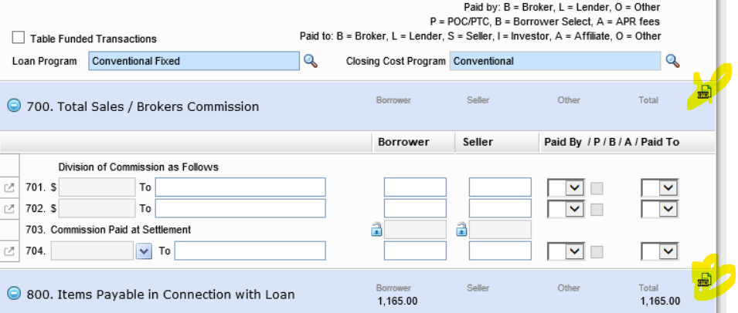
Section 900 – Items required by Lender to be paid in advance - check the dates for interest and check prepaids – if dates are incorrect you can click on the arrow on the left and adjust the info.
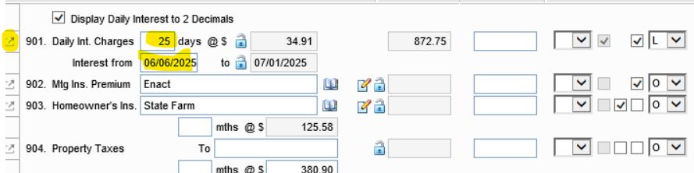
Arrow on the left brings up a new popup box
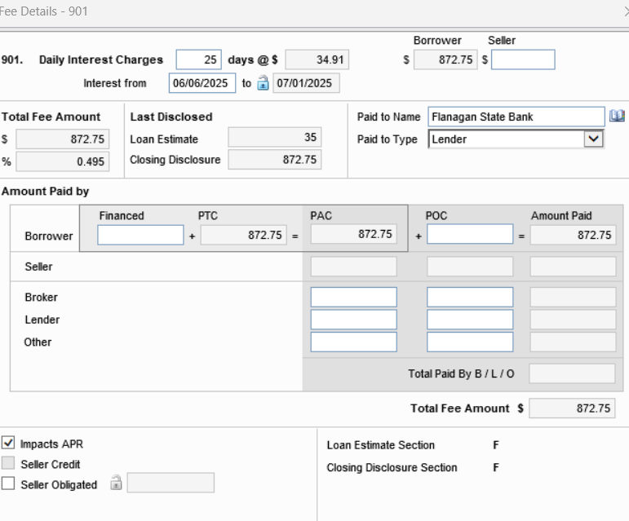

Section 1000 – Reserves – this is where you set up the aggregate information

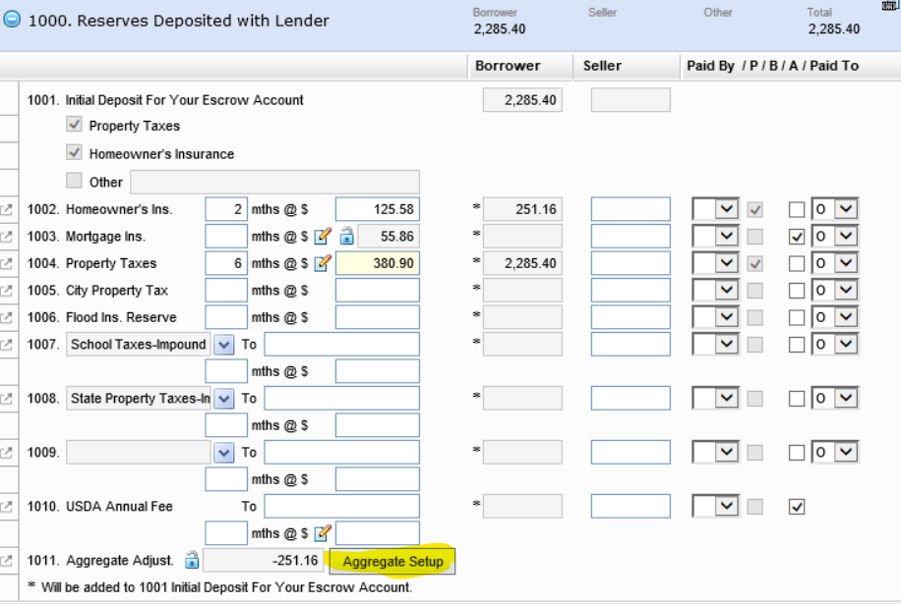
Click the Aggregate Setup and fill in the dates
If you have MI you will need to put a “1” in 12 times so it will fall into the escrow analysis
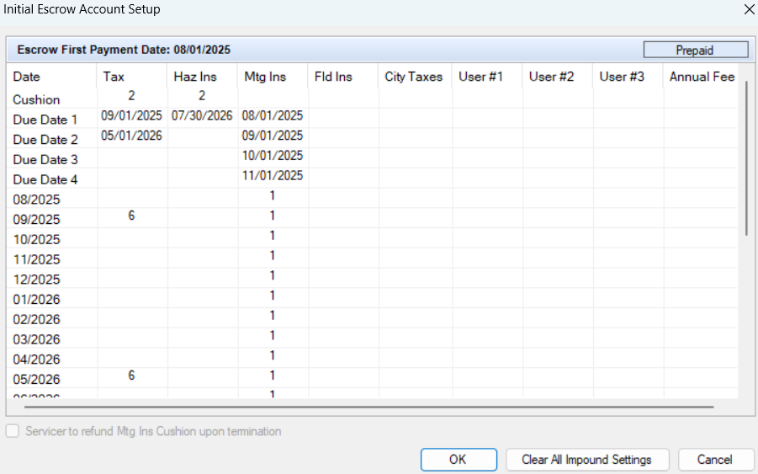

Section 1100 – Title Charges
The arrow on the left pulls up a popup box to make corrections to fees
Borrower shop for – etc
APR fees are hard coded
You can hold “ctrl” button and click on the field and get an explanation of that field
You also have the film in the upper right corner that you can click on for a tutorial for that section.
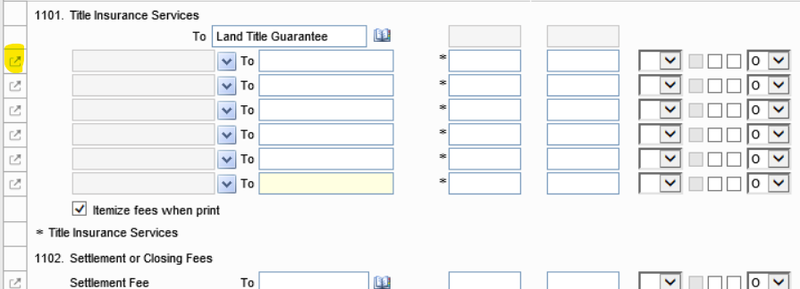

- Aggregate Escrow Screen – click on in the left side
You can set up your escrows in this section as well – fill in your pay to section
For MI – you can edit by clicking on the pencil and a popup box will appear
You will need to check one of the boxes – usually “Charges for the insurance are added to your loan payments” box
You might have to add for Conventional MI, but should pull through if we order through Encompass
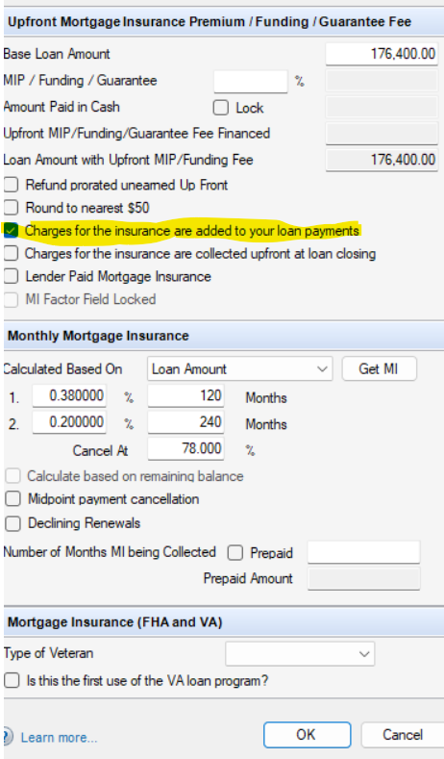

If have school or state taxes – click the edit button by the “pay to” – a popup box will open and you will need to check the box to the appropriate item whether it is tax or insurance and fill in the information
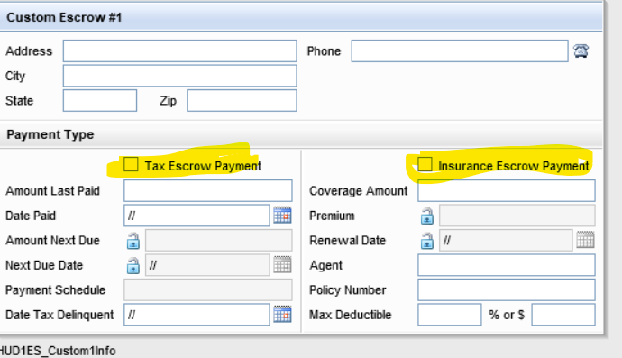

Additional Info – all payout dates need to be within the first 12 months from closing.
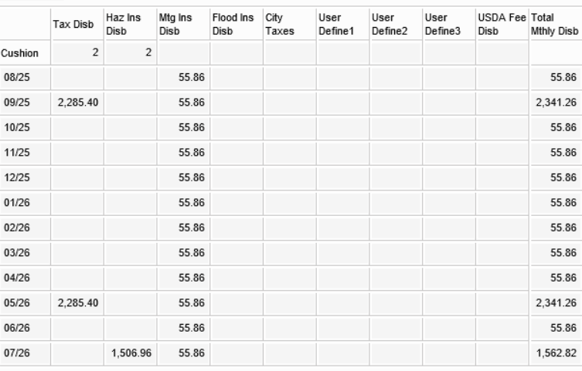

- Closing Disclosure page 4 – review the information to insure correct. The late fee should pull through according to product.

- Closing Disclosure page 5 – review the information to insure correct. The lender name information should pull through from the 1003
The Settlement Agent information is required to be able to create docs.
Very – Important
Look Up State Matrix for “Other Disclosure” section.
Locate your State for either the “Top” or “Bottom” checkbox.
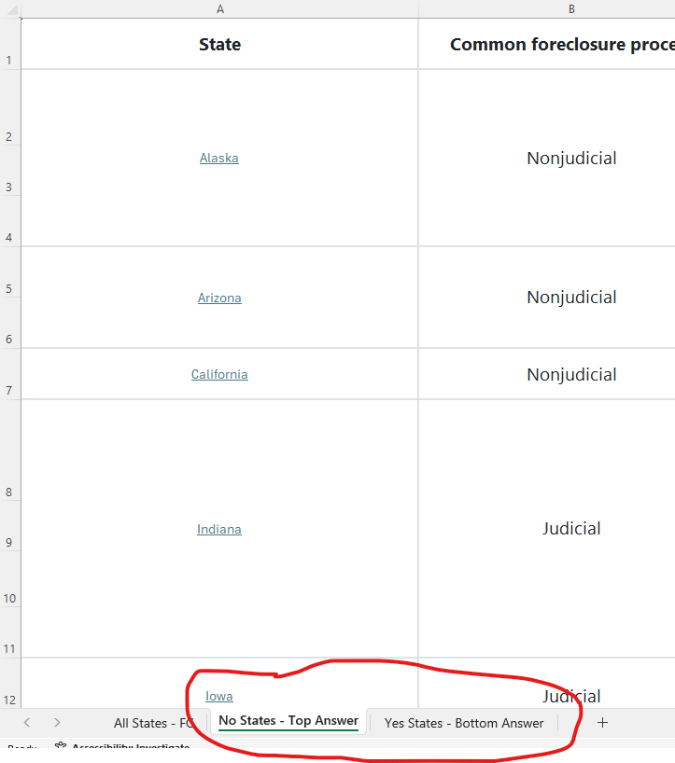

- Closing Conditions – Draw City and Draw State are required
If you fill in the closing County and State it will show up in the notary section of your documents – you can leave it blank.
Ignore Hours Docs needed and termite report required
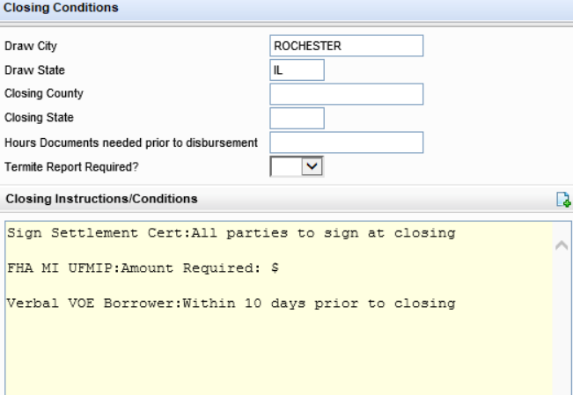
Conditions can be created by using a conditions set or by individually choosing conditions or create your own. Click on the paper/arrow in upper right corner and a popup opens. Choose one and hit ok
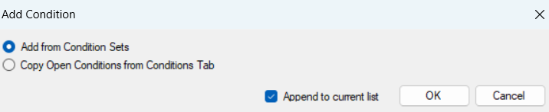

Sets you would pick the set and add to the right side
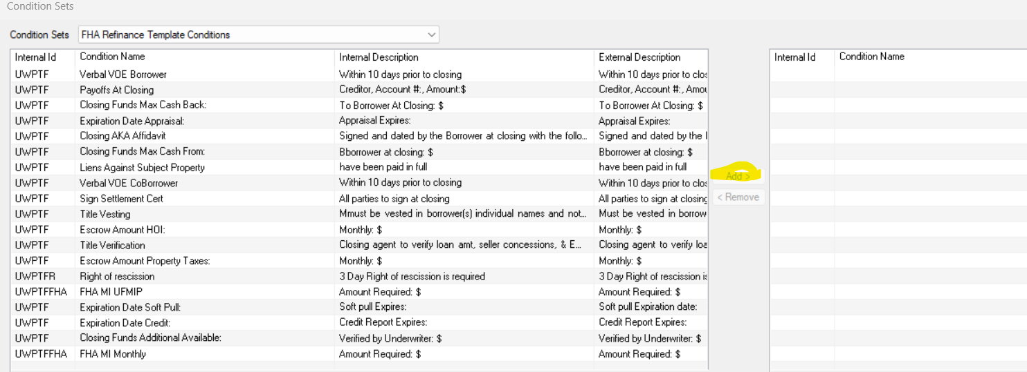
If you pick Copy Open Conditions it will pull through conditions from the underwriter and you can add your own.
- Request for Transcript or Tax on the left
Choose if the tax from is for both by the drop down menu – you can copy the information borrower summary – review the information and it should auto fill the years needed for tax transcripts at the bottom of the form.
You can check a different box if you would need W-2’s, etc.
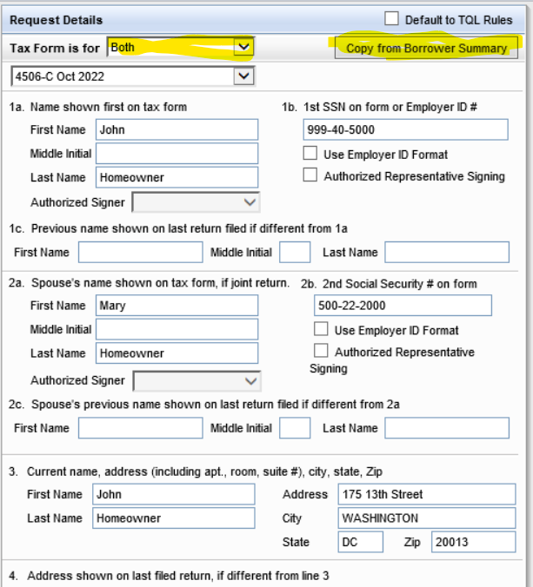

- RegZ-CD – First pick a plan code - 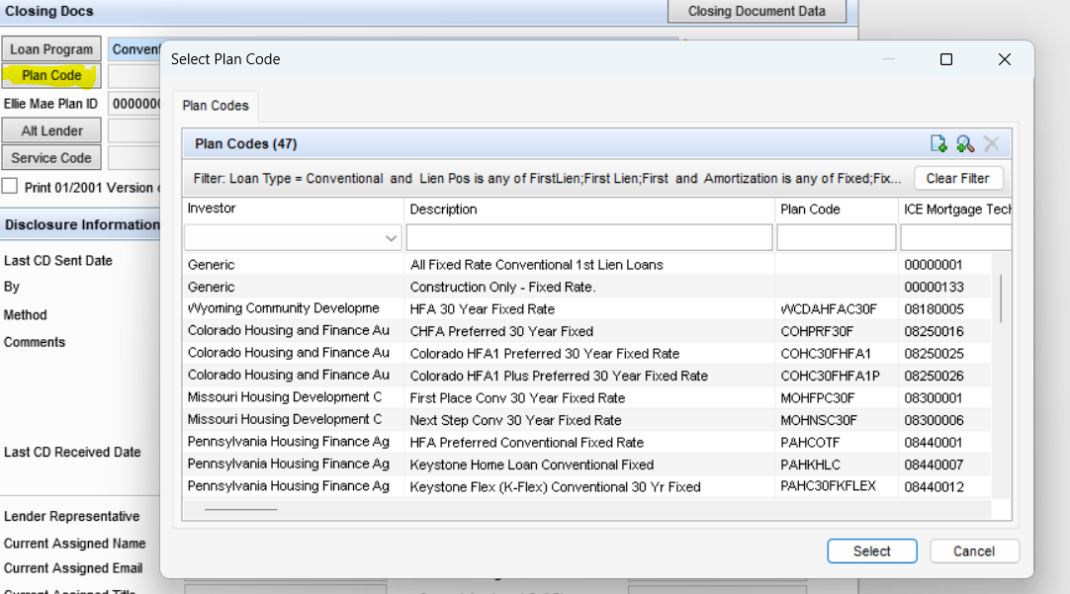
Check Disclosure Information and Loan Information
Check 1st payment date and CD Date Issued – add your document date, closing date and signing date. If refi it will calculate for you the rescission date and disbursement date. You can hold crtl button and press D and it will put today’s date in the field
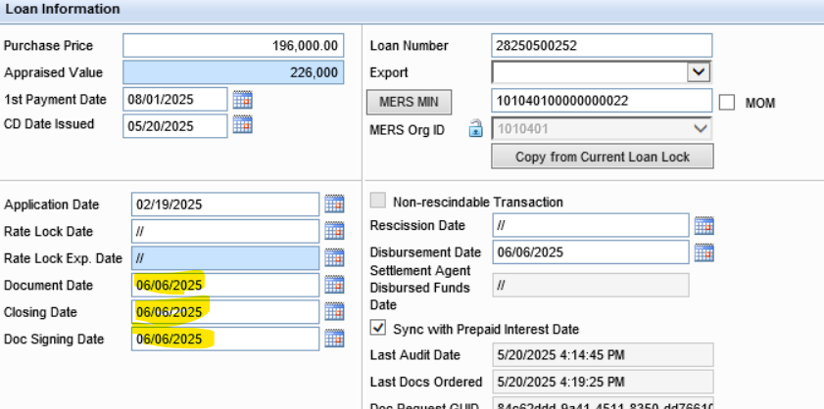
Check the rest of the info to insure accuracy – purchase, conventional etc
If you have a construction loan fill in that section or on the left click on Construction Management and fill in the information and it will pull through.
There is also a FHA Management on the left you can fill in the information for FHA – the case number should pull in once it has been ordered by the processors
F1 will bring up a help window
You can order docs from several places: (upper right corner)
Borrower Information Vesting
Property Information
Reg Z – CD
Once you click order docs a window opens – if in red – it is required to fix before you can move on – once corrected you can click on the drop-down in the top left hand corner and select “Pre-Closing” instead of “Closing

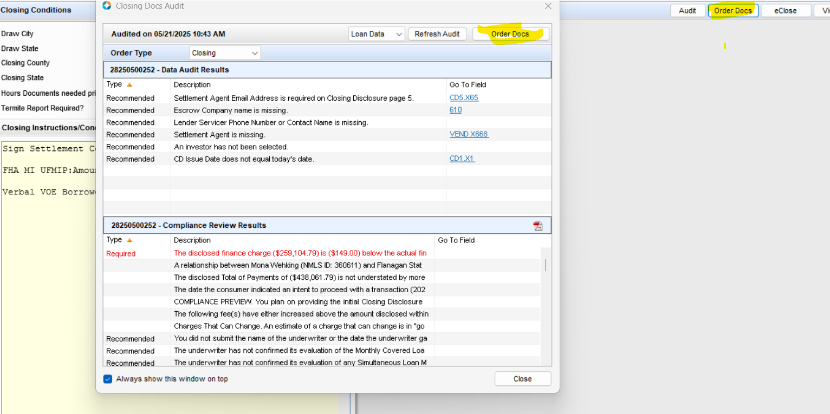

Your compliance review will show up in the Mavent report – the Mavent is called the Compliance Report which is in the list of docs to add.
Pick your order type as “Pre-closing”
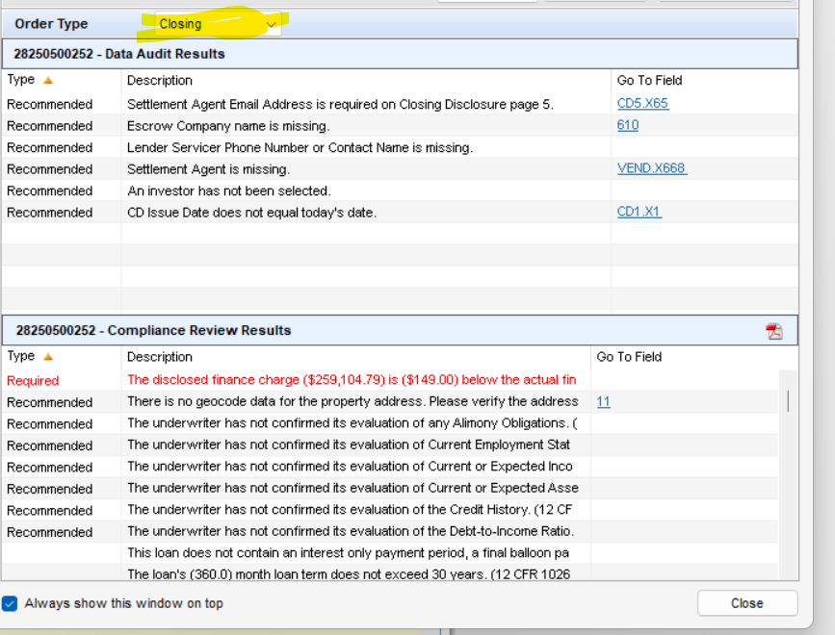
Click order docs again and you will need to choose
When you send - a pop up opens for you to verify who you are sending to. At the bottom you can pick additional users to send to. You can get notified if the borrower doesn’t access by a certain date
