You have an alternative loan product and you and APT have determined what product and what lender…. What’s next:

When starting an APT loan

Step Number 1 – Initial Encompass Loan Setup:
- Before starting anything go to Easy Data Entry and complete the following:
  - Product Code
  - Investor Name
  - Once you are done entering this information please save the file. You will see that our rule base will setup the milestones to reflect the brokered loan process instead of a regular Agency loan automatically.

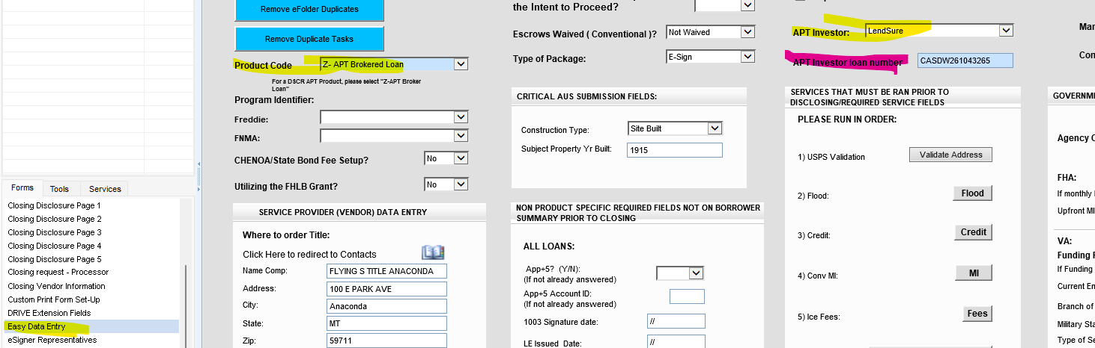
- Navigate to the Top Left of the Borrower’s Summary Origination Form within Encompass. If this field (2626) does not say broker, please reach out to MIT right away.

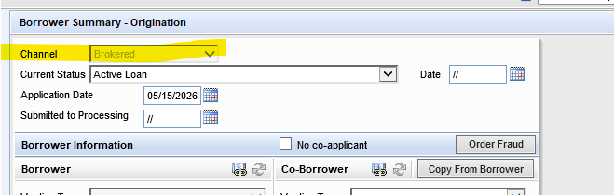
- Later you will get the investor loan number. Once you have started the file with the lender. Please enter it at that time!

- Once the loan is stated as a Brokered loan, you will NOT be able to send out disclosures or change the loan back to an agency loan product.

  - If later you want to do an Agency loan for the same applicants, you MUST start a whole new loan within Encompass. We suggest you use the export and import option. DO NOT duplicate the loan.
  - If after researching an APT loan and the applicants no longer qualify and you need to DENY the loan, remember that all brokered loan products must be denied under the “Prequal Denial” section on the denial form within Encompass. Please also remember to finish the application milestone for our Compliance team to receive that automated email. Brokered loans are NOT HMDA reportable, hence this policy.

Step Number 2 – Starting the APT Loan within Encompass once ready for Lender Submission:

Now enter the following information for processing and commission purposes.
- Now it is time to complete the URLA- TAKE A FULL APPLICATION-Make sure the info you are entering is correct This will save you or your processor time later throughout the process by being able to export the full application and import it to the lender’s website.
  - Except for HELOC loans, and ITIN (see notes below for these two types) you should be importing your credit report. You cannot determine if you have a potential qualified borrower without a credit report.
- Loan Amount
- Interest Rate
- Loan Term
- You can add more to the Easy Data Page that may help your processor later:
  - Title company
  - Homeowner’s insurance company
  - Notes to the processor

Step Number 3 – Preparing each loan for processing / Lender Submission:

That is also a good time to send out a borrower’s authorization for Flanagan State bank- the reason: the borrower will sign one with the lender that is being used, but that form will not let us order verifications and credit supplements. We need to have one with Flanagan State Bank in the file manager so the processor can process.

Most of the lenders will need our 1003 and/or a 3.4 (see below if lenders require specific information on the URLA- example, Lendsure requires subject address to be listed as TBD for a purchase file -you can add address once you have created your 3.4 file-see below), if the file is a DSCR, you won’t add income on page 2, bank statement or P&L loans, add the income that has been determined by the chosen lender during the prequalification stage) -

Steps for Creating the 3.4
Once your file is ready to create a 3.4 here are the steps-
- Exit your file and go to your pipeline view.
- Rt click on the loan
- Scroll to GSE Services
- Go to ULAD (DU MISMO 3.4) or the iLad (MISMO 3.4) this will be noted on the specific lender instructions.
- Download and save it to your desktop, this will be sent once ready


Helix –With REMN, they will pull a soft pull themselves, but it’s a good idea to have your own. Forward Lending also requires just a soft pull; this can be pulled by the LO or the Forward Lending.
ITIN-The lender will pull their own report – TRANSUNION only, but it’s also a good idea to do a soft pull for Transunion yourself as well.

OakTree Processing Guide
Account Setup
Need Portal Access?
APT can assist with obtaining your OakTree login credentials.

Contact:
- Email: tdavis@mtgbyallison.com
- Phone: 765-413-8806

Account Executive
Zia Hasso
- Email: zhasso@oaktreefunding.com
- Phone: Direct: 602.600.6855; Cell: 623.512.5556; Fax: 480.857.8080
Account Manager
Deanna Yu
- Email: Dyu@oaktreefunding.com
- Phone: 480-801-6811

Appraisal related questions: 480.801.9335
appraisalteam@oaktreefunding.com

When starting a loan with OAKTREE review this PowerPoint-

https://youtu.be/SgUJoexjDhY (copy and paste into your search bar or right click on link and scroll to open hyperlink.)

The presentation will give instructions for each step-

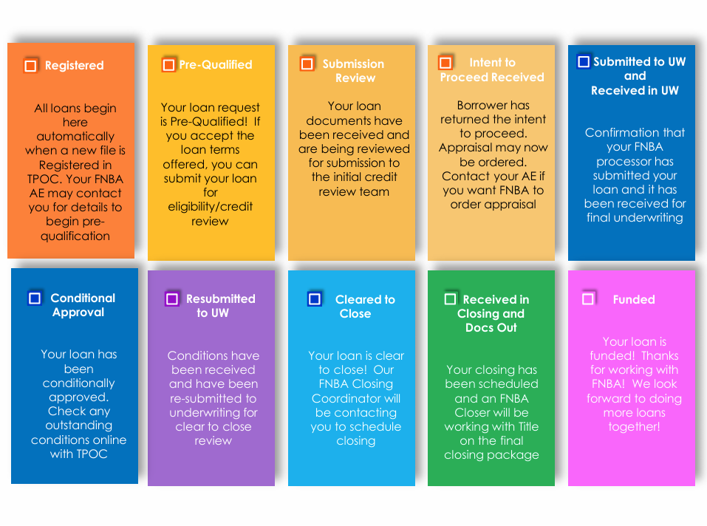

To review matrix for the many programs and products Oaktree has to offer:
Non-QM Done Right - Oaktree Wholesale (right click on link and scroll to open hyperlink to take you to products)

Resources - Oaktree Wholesale (right click on link and scroll to open hyperlink to take you to resources) here you will find needed forms for submission, doc order form, Business Narrative form for Bank Statement Program, Submission Checklist, Etc.

Mortgagee:
OAKTREE FUNDING CORPORATION, ISAOA 3133 WEST FRYE ROAD, SUITE 205 CHANDLER, ARIZONA 85226

Once the loan has been funded:
Update loan amount, income assets etc. in encompass, to match the final approval from the lender and then let APT know the file has funded.
Email: apt@flanaganstatebank.com
Title will need to mail the broker check- the address they will need to mail this to is:
Flanagan State Bank
Attention: Loan Servicing
P.O. Box 368 (needs to be listed for regular mail)
301 W. Falcon Hwy.
Flanagan, IL 61740
FOR DSCR LOANS- DO NOT PUT INCOME IN ON PAGE 2 IN ENCOMPASS, these loans do not use income to qualify. Make sure when ordering an appraisal, you will need a rent schedule.
FOR BANK STATEMENT OR PROFIT AND LOSS - use the income that had already been determined before starting this loan. (your LO should have done this part).

Please call, email or message me on teams if you need any help with anything. How to complete a step, understanding a condition, or a specific process.
We are considered the broker, and the APT investor is considered the lender.

