ENCOMPASS TRAINING FOR ALL STAFF
Overall Use:
Please review the custom links that we have added to Encompass. These can be helpful.
You also can see who is currently logged into Encompass. Only ONE person is allowed into a loan in Encompass at one time.
*If a staff member is accidentally is in a file and another staff member needs access to that file, please email MIT@flanaganstatebank.com and we will get you access to that loan. Note, the last edits made by the previous staff member will NOT be saved.
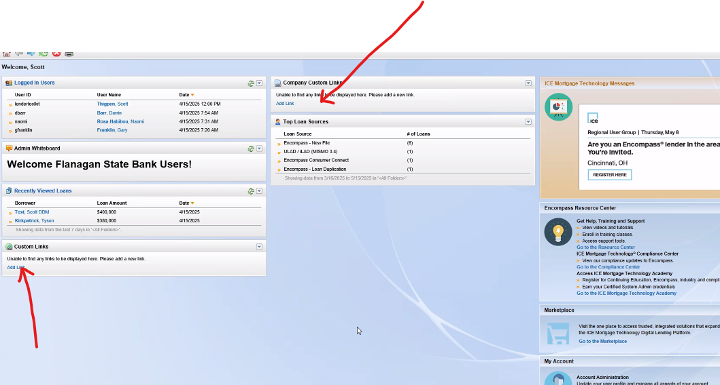

Helpful Key Strokes:
Control G = Allows you to find ANY field within Encompass. This may help you from time to time with rule-based items.
Control D = Enters today in any date field.

Updating your Personnel Information including Phone Numbers:
If you need to update your personal information including your phone number, you can do so under “Settings”. You can update your profile here.
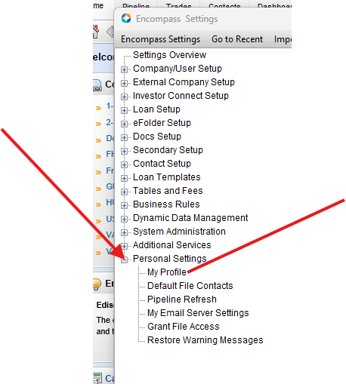

Pipeline Views:
In Encompass you can set up your own pipeline view VERY similar to how you would create a report. This will help you track those items that are most important to you or your branch.
On ANY column simply right click to add another field. You can then drag that column anywhere you want in order. Then remember to SAVE you view.
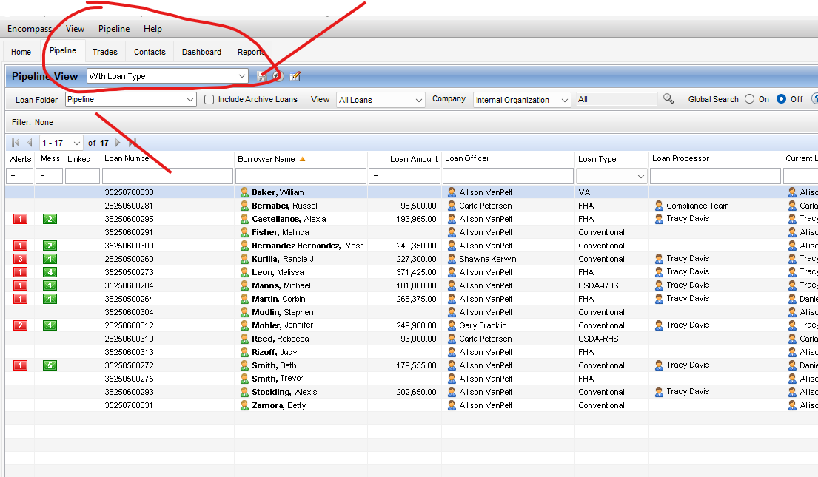

Rolodex Entry Labels and Business Contact:
Every branch is allowed to add both Borrower Contacts AND Business Contacts into the loan. Simply select “Contacts”. Please make sure that you use a business category when setting up Business Contact. The more complete these are when established the less information other departments will have to complete on your loans. After you have added these, in many spots in Encompass you will see this icon to simply add the information.
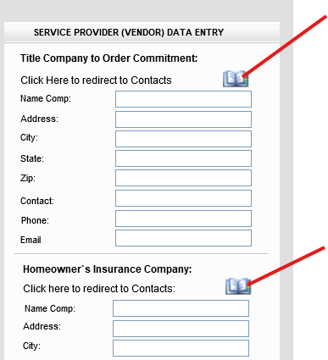
Every branch is allowed to add Business Contact for up-to the first 90 Days. Please make sure to NOT add duplicate listings to keep the database as clean as possible.
When you first use your Business contacts remember to add “Category” to your view and then save it for future use. You also must remember to hit the “Clear” button in the top right hand corner each time you add a new contact. Then do not forget to hit Save!
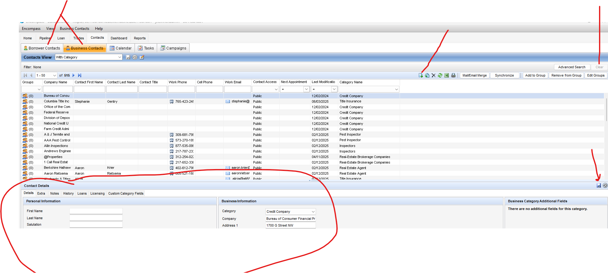

Encompass Rule Base:
Built within Encompass is a vast rule base that will help producers and operational staff with increased efficiency. Sometimes you will receive “Auto Email” notifications during the loan process. Some are reminders for process flow, and others are information as it pertains to the individual loan. There also are rules that require fields before disclosing, and moving data entered to other areas within Encompass (Field Triggers). Lastly, there are required documents rules at certain milestone completions.
If you are having trouble accomplishing a task due to a rule, please make sure to email MIT@flanaganstatebank.com and we will help you with it ASAP.

Understanding the Alerts and Log Section of Encompass:
Once you open any loan within Encompass in the top left-hand side of all loans are the Alerts and Log Section. The Alerts are simply advising all staff members of required compliance or underwriting items as the loan progresses throughout the loan process. Please make sure to pay attention to those. If you ever have any questions in regard to the alerts, please email MIT@flanaganstatebank.com .
The Log is how staff members locate the “status” and move loans within Encompass. Each loan is moved by completing the Milestone assigned to each staff member.
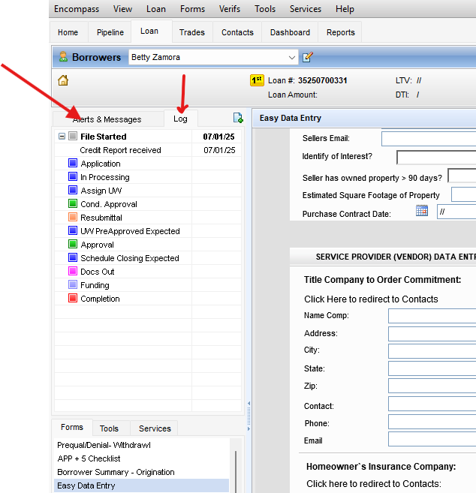
Only ONE person can make edits in Encompass at one time:
If there is a person in a loan and you try to get into the loan, Encompass does inform you who is already within the loan. Please contact your co-workers first to ask them to get out of the loan. It should only be under extreme circumstances we need to assist, but we can kick them out of the loan when necessary. Email MIT@flanaganstatebank.com when that is needed.
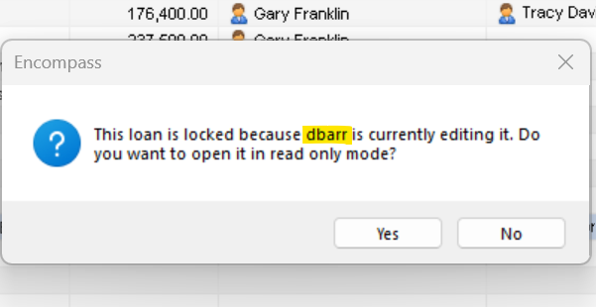
IN ADDITION, PLEASE REMEMBER TO LOG OFF FROM ENCOMPASS EACH EVENING. MANY TIMES CRITICAL UPDATES ARE DONE DURING EARLY AM HOURS.

Understanding the “Loan” Menu in the Very Top Menu:
The Loan Options at the top of the page allows you to apply certain features on all loans. The one you may use the most is the “Apply Input Form Set Template”.
This allows all departments (LO’s, Processors, Underwriters, Closers, Post Closers, Secondary, and Compliance to see ONLY the forms they want to utilize on a loan by loan basis.

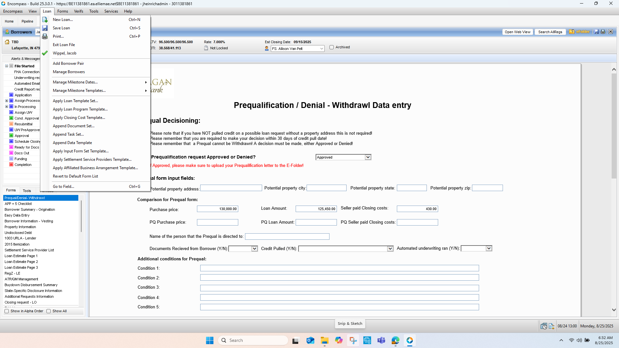

Getting familiar and Understanding the URLA:
Note that Encompass does not look the same as other LO’s as to the look and feel of the actual URLA (application). Please review all the pages of the URLA Lender Form in Encompass to refamiliarize yourself with an actual application.
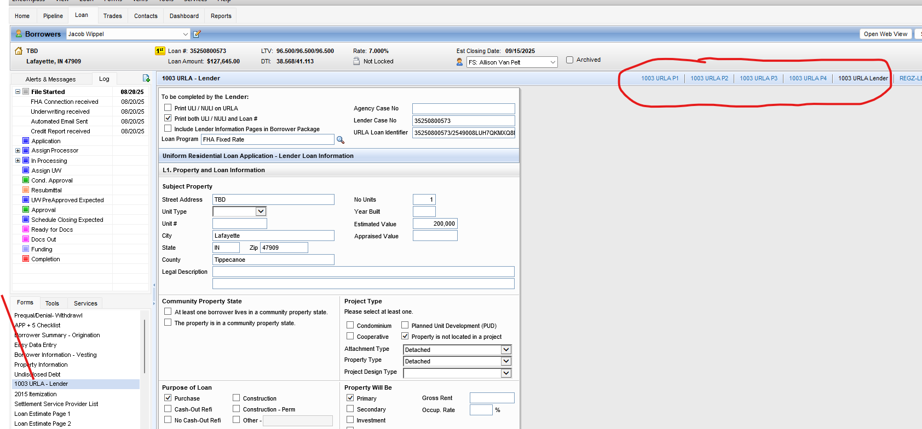

VERY IMPORTANT:
All Users must have “Outlook”, not just the web-version of Outlook engaged and setup. Simply click the Microsoft button, select Outlook and then simply complete the Wizard.
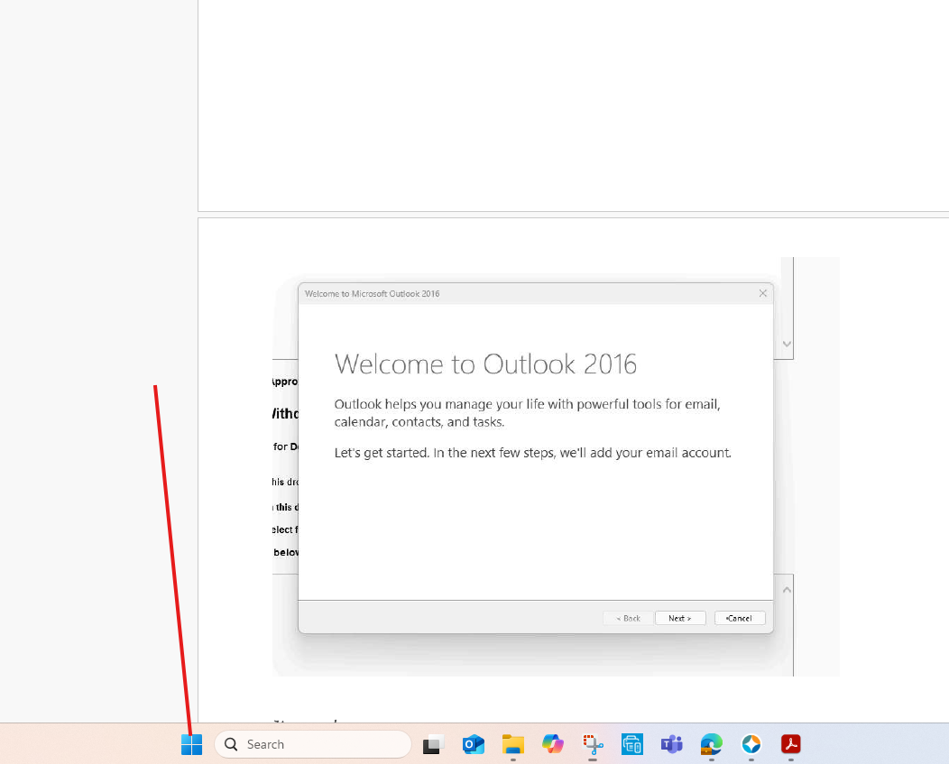
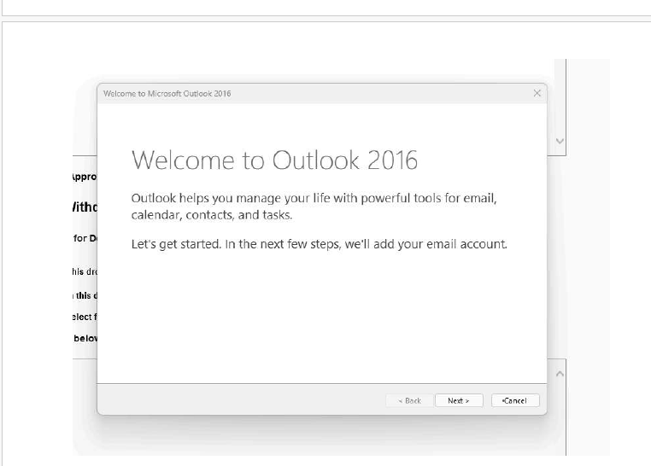
Helpful Training Videos:
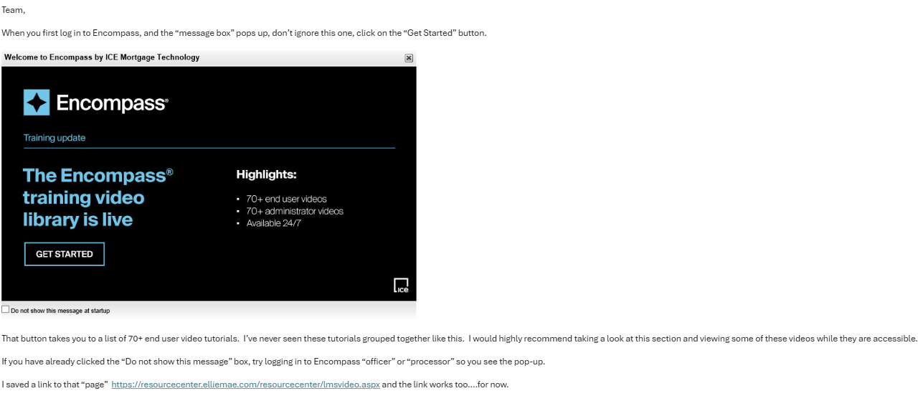

MIT is your “Friend”:
If you have any issues with access to loans or require further help simply email MIT@flanaganstatebank.com and give us 30 minutes to respond. We will help you along with Encompass.

